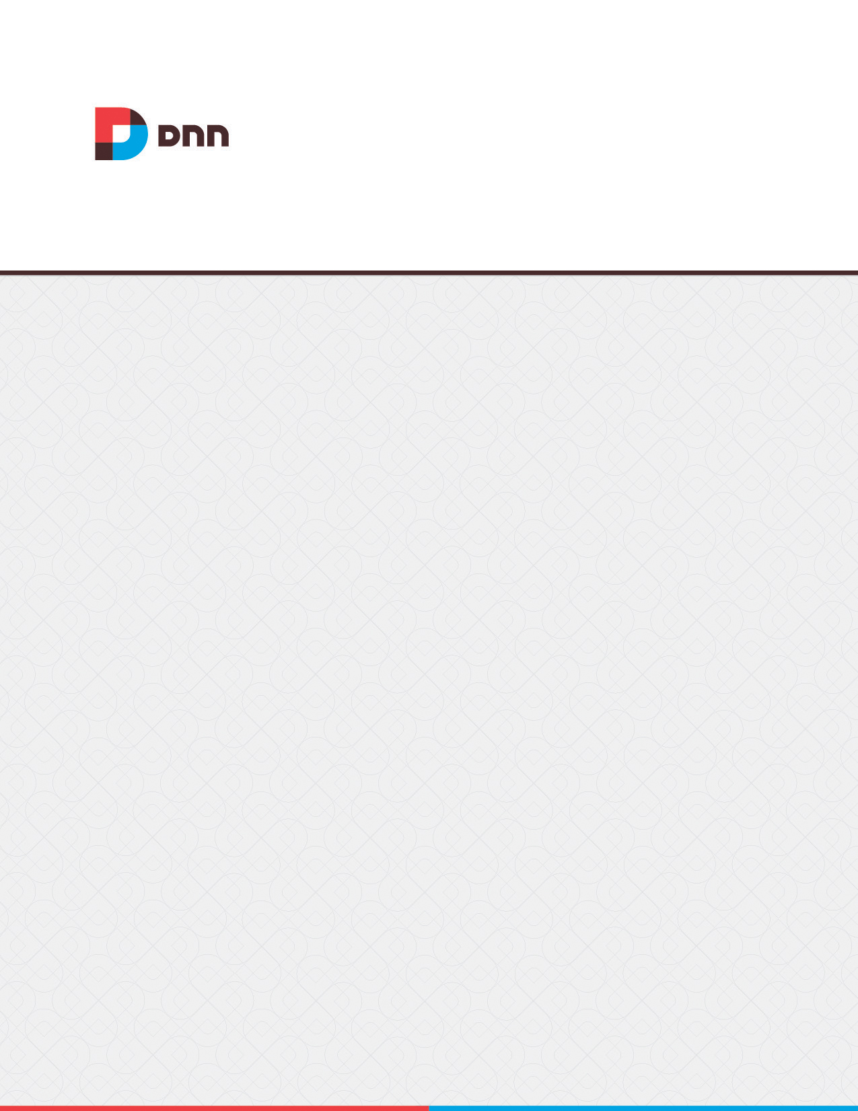

**Forum 05.00.03**

**User Manual**

Contents

Forum 5

All Users 5

Downloading a Post Attachment 5

Filtering Threads from a Single Forum 6

Go to Forum Home Page 7

Navigating Threads 8

Navigating to Forums & Forum Groups 9

Navigating Using Breadcrumbs 10

Searching a Single Forum 11

Searching One or More Forums 12

Viewing a Forum as an RSS Feed 14

Viewing any Post 15

Viewing Latest Posts 16

Forum Administrators 17

Overview of the Forum Administration Page 17

Navigating to the Forum Admin Page 18

Control Panel Section 19

Configuring General Forum Settings 19

Configuring the Forum Community Management Settings 20

Configuring the Forum Search Engine Optimization 21

Enabling/Disabling Attachments 22

Managing RSS Feeds 23

Content Section 24

Adding a Filtered Word 24

Deleting a Filtered Word 25

Editing Filtered Words 26

Enabling/Disabling Word Filtering 27

Filtering Filter Words 28

Managing Forum User Ranking 28

Managing Popular Thread Status 30

Managing Rating of Threads 30

Email Section 31

Managing Email Settings 31

Managing Email Templates 32

Viewing Email Subscribers Report 34

Forums Section 34

Adding a Forum Group 34

Adding a Forum 35

Deleting a Forum Group 37

Deleting a Forum 38

Editing a Forum Group 39

Editing a Forum 40

Enabling/Disabling a Forum 40

Loading Existing Forum Permissions 41

Re-Ordering Forum Groups 43

Re-ordering Forums 44

Setting Forum Email 45

Setting Forum Options 46

Setting Forum Permissions 47

Users Section 49

Configuring System Avatars 49

Configuring the Default Forum User Interface 50

Editing any Forum User's Profile 52

Editing any Forum User's Signature 53

Editing Global User Settings 54

Enabling User Avatars 55

Searching Forum User Accounts 56

Forum Members 58

Adding a Bookmark to a Thread 58

Adding a Forum Post (Basic) 59

Adding a Forum Post (Advanced) 61

Deleting a Forum Post 63

Editing your Forum Posts 65

Editing your Forum Profile 66

Editing your Forum Settings 66

Editing your Forum Signature 68

Manage Notifications 68

Managing Forum Bookmarks 69

Moving a Thread 69

Quoting a Post 70

Rating a Thread 73

Replying to a Post 74

Reporting a Post 75

Setting Thread Status 78

Splitting a Thread 79

Viewing your Posts 81

Viewing your Threads 82

Forum Moderators 83

Approving a Post 83

Approving and Editing a Post 84

Approving and Replying to a Post 86

Approving and Splitting a Post awaiting Moderation 88

Deleting a Post awaiting Moderation 89

Managing Reported Posts 91

Navigating to the Moderator Post Queue 91

Viewing Banned Users 92

Viewing Reported Users 93

Settings 93

Default Forum 93

Setting a Single or Aggregated Forum Group 94

Setting Additional Forum Permissions 95

# Forum

The Forum module manages multiple discussion groups and forums. Each forum post includes a subject title and content. Optional settings include the ability to quote an existing post, enable post attachments, pinning a post, notification of replies posts, lock posts, as well as manage user settings and a wide range of Administration options.

**Installation Note**: This module must be deployed and installed on your site by a Super User.

**Module Version**: 05.00.03 / **Minimum DNN Version**: 06.00.00

**Features**: IPortable, ISearchable, IUpgradable

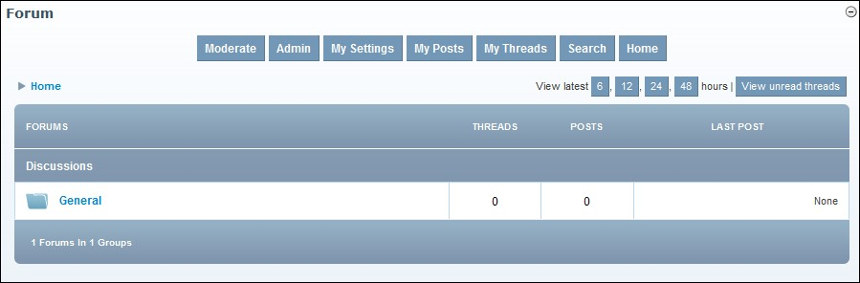

The Forum Module

***Project Links***  <http://dnnforum.codeplex.com/>

# All Users

## Downloading a Post Attachment

How to download an attachment associated with a post on the Forum module. Note: Attachment download maybe disabled, enabled for all users, or restricted to authenticated user.

1. Navigate to the required post. The attachment is displayed below the body of the post.
2. If the message "Login to download attachment" is displayed, anonymous download is not permitted. In this case you must login to download the attachment.
3. Click on the **Attachment** icon or the [Attachment Name] link and then save or open the attachment as required.

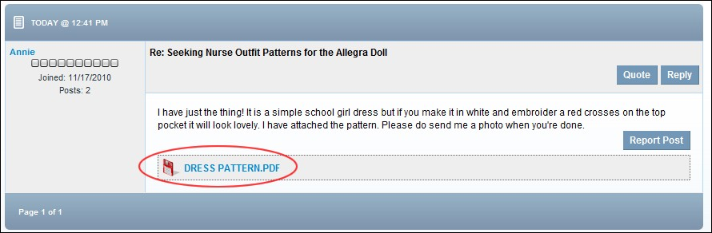

Downloading an Attachment

## Filtering Threads from a Single Forum

How to filter the threads which are displayed for a single forum.

1. Navigate to the required Forum. See "Navigating to Forums & Forum Groups"
2. At Display Thread From (located in the bottom right corner of the module), select a timeframe to filter thread by from these options: **Today**, **Past Three Days**, **Past Week**, **Past Two Weeks**, **Past Month**, **Past Three Months**, **Past Year**, **All Days**. This displays all matching threads.

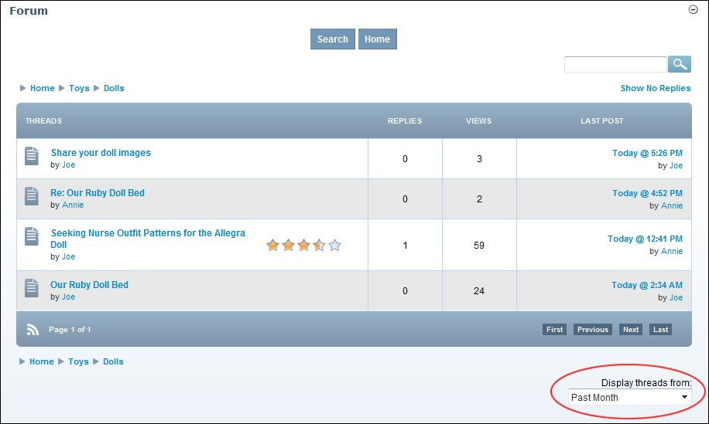

Filtering Threads from a Single Forum

## Go to Forum Home Page

How to go to the home page of the Forum module.

1. Click the Home link located in the top left corner of the breadcrumb - OR - Click the Home link located top center above all forum groups.

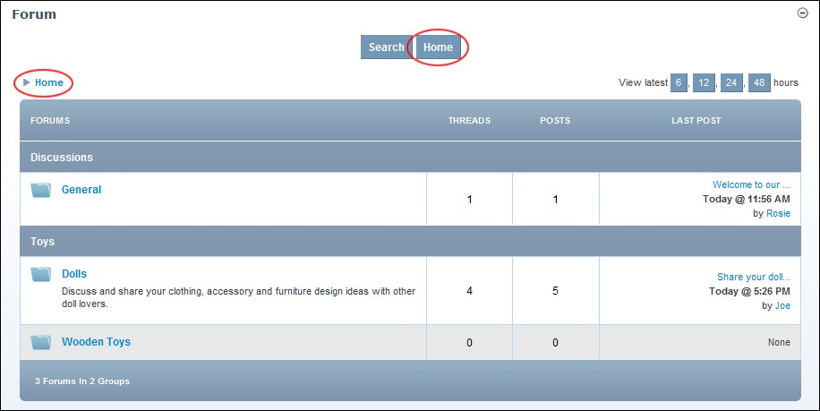

Go to Forum Home

## Navigating Threads

How to navigate to threads which are not displayed in the Forum module.

1. Navigate to the required Forum. See "Navigating to Forums & Forum Groups"
2. Use the First, Previous, Next and Last links to navigate to threads not currently displayed.

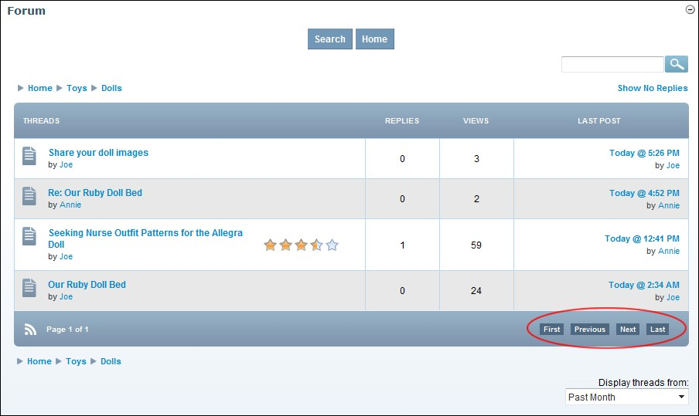

Navigating Threads

## Navigating to Forums & Forum Groups

How to navigate to forum groups, forums, threads and posts from the Home page of the Forum module.

Option One: One: Click on the [Forum Group Name] link to go to a Forum Group

Option Two: Click on the [Forum Name] link to go to a forum

* **Optional**. Click the Show No Replies or Show With Replies link (located under the Search box in the top right-hand corner of the module) to modify the threads are displayed.
* **Optional.** Change the order of threads from Oldest To Newest or Newest To Oldest by selecting either option from the drop down list located in the bottom right corner of the page.

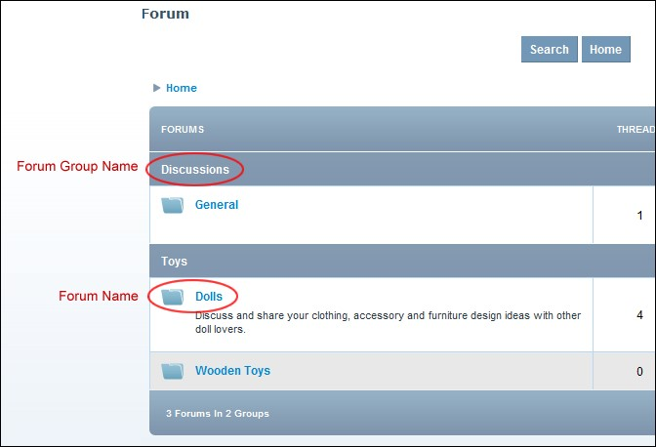

Navigating Forums

## Navigating Using Breadcrumbs

Breadcrumbing of forum names enables you to quickly view other forums without returning to the Forum Home.

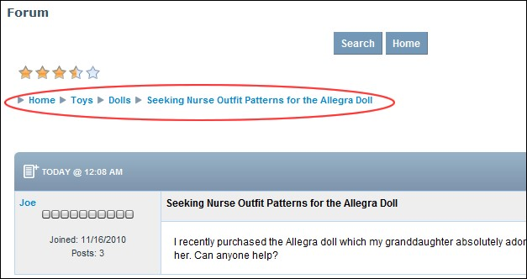

Breadcrumbs enable users to quickly navigate Forums

## Searching a Single Forum

How to search for a post within a single forum.

1. Navigate to the required forum.
2. In the **Search** text box, enter your search criteria.
3. Click the **Search**  button. The search results are now displayed and the search phrases, words are highlighted in yellow. If no results are displayed then no results were found.

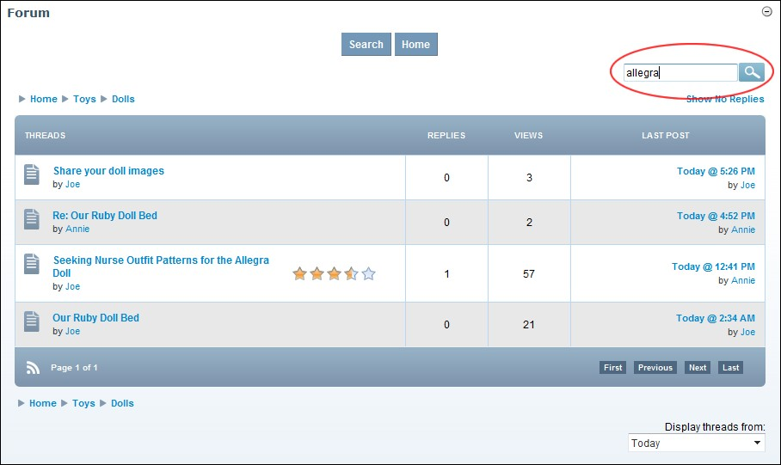

Searching a Single Forum

## Searching One or More Forums

How to search for posts within one or more forums using the Forum module.

1. Click the Search link located in the top center of the module. This opens the Search Forum page.
2. At **Post Dates** set the dates you want to search through. This default setting is for the previous one month. If this range is suitable and you don't wish to set any further criteria, skip to Step 4. To change this date range:
   1. At **Start**, click the **Calendar**  button and select a new start date.
   2. At **End**, click the **Calendar**  button and select a new end date.
3. The following additional search criteria is available:
   1. In the **Subject Contains** text box, enter a word, phrase or number to limit the search to posts that contain the entered criteria in the subject.
   2. In the **Body Contains** text box, enter a word, phrase or number to limit the search to posts that contain the entered criteria in the body of the post. You can search for individual phrases, by separating them with a comma. E.g. (phrase1, phrase2, phrase3)
   3. At **Threads Status**, select a thread status to limit your search to threads of that status. Options are: **Any Status**, **Unresolved**, **Resolved**, or **Informative**. If a forum doesn't have a thread status set then this field is ignored.
   4. At **Search In**, click the **Maximize**  button beside a forum group to view the related forums and mark  the check box against one or more individual forums.

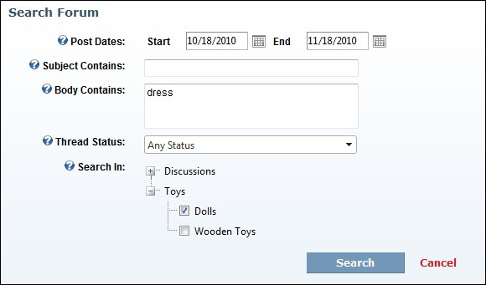

1. Click the Search link. The search results are now displayed and the search phrases, words are highlighted in yellow. If no results are displayed then no results were found.

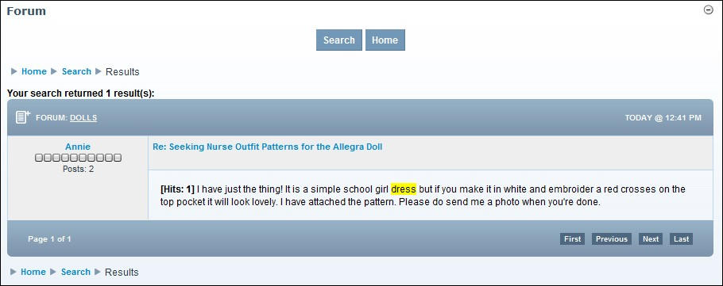

Search Results Displayed in Forum Module

## Viewing a Forum as an RSS Feed

How to view a forum as an RSS feed using the Forum module.

1. Navigate to the required forum. See "Navigating to Forums & Forum Groups"
2. Click the RSS button located at the base of the page.

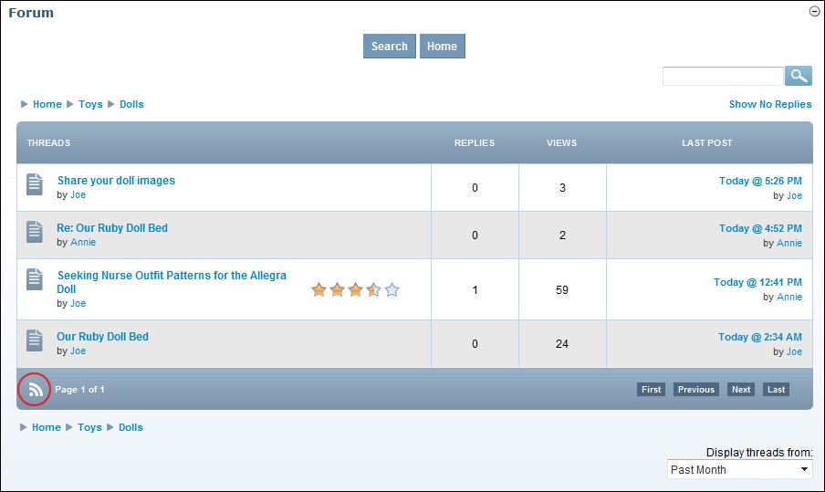

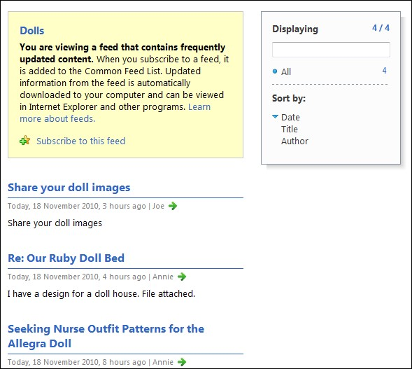

## Viewing any Post

How to view a post that has been posted to a Forum.

1. Navigate to the Forum where the post has been added. See "Navigating to Forums & Forum Groups"
2. Click on the [Thread Name] link to open the thread and view the related posts.

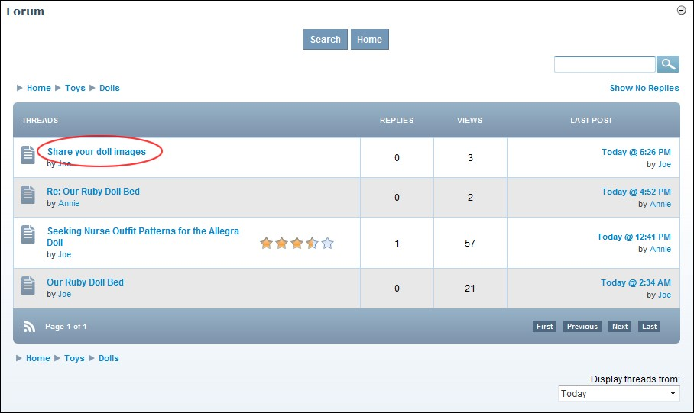

Viewing any post

## Viewing Latest Posts

How to view only the latest posts to all forums within the Forum module.

1. Go to the Forum Home page. See "Go to Forum Home Page"
2. At **View Latest**, select to view posts added within either the last **6**, **12**, **24**, or **48** hours.

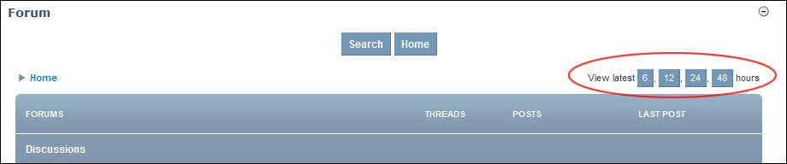

Viewing Latest Posts

# Forum Administrators

## Overview of the Forum Administration Page

The Forum Administration page enables Administrators and Forum Administrators (See "Setting Additional Forum Permissions" to set up this permission) to manage all aspects of the forum module, such as Groups, Forums, Users, Features and Email Notifications.

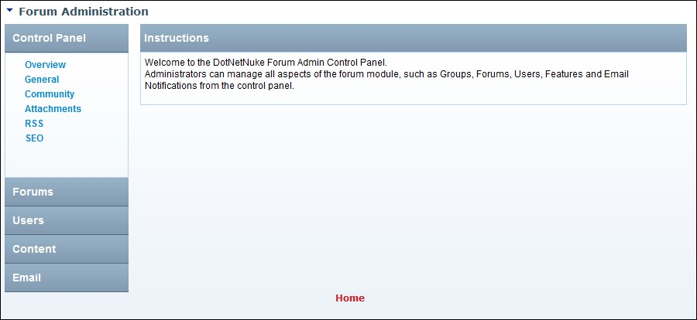

The Forum Administration Home Page

**Control Panel Section**

* **Overview**: Brief description of the Forum Administration section.
* **General**: Manage general global forum settings.
* **Community**: Used for integration with third party modules
* **Attachments**: Enable/disable file attachments
* **RSS**: Enable RSS Feeds
* **SEO**: Manage the way forums are handled by search engines

**Forums Section**

 **Forum Manager**: Manage new and existing forums and forum groups.

**Users Section**

 **Users**: Manage individual user profiles, signatures, avatars, forum access and set users as trusted

 **Avatars**: Manage default avatar settings

* **User Settings**: Manage default user settings
* **User Interface**: Manage default forum interface settings

**Content Section**

* **Filter Settings**: Enable/disable word filtering
* **Filter Words**: Set filtered words and their replacement words
* **Rating**: Enable and manage user ratings
* **Ranking**: Enable and manage user ranking
* **Popular Status**: Manage popular thread settings.

**Email Section**

* **Email Settings**: Manages email settings.
* **Templates**: Manage templates for emails sent to users and moderators.
* **Queue**: Only available if the scheduled task is on and the email queue is enabled, allows hosts to set a time frame for keeping email queue related data.
* **Queue Tasks**: Only available if the scheduled task is on and the email queue is enabled, allows administrators to see the most recent emails that have been queued up, along with who is receiving them and if the sends were successful or not. 
* **Subscribers**: Displays a list of forum notifications at the forum and thread levels.

## Navigating to the Forum Admin Page

How to navigate to the Forum Administration page, also called the Forum Admin Control Panel, of the Forum module. Access to this page is restricted to Forum Administrators.

1. Click the Admin link- OR - Select **Admin** from the Forum module actions menu.

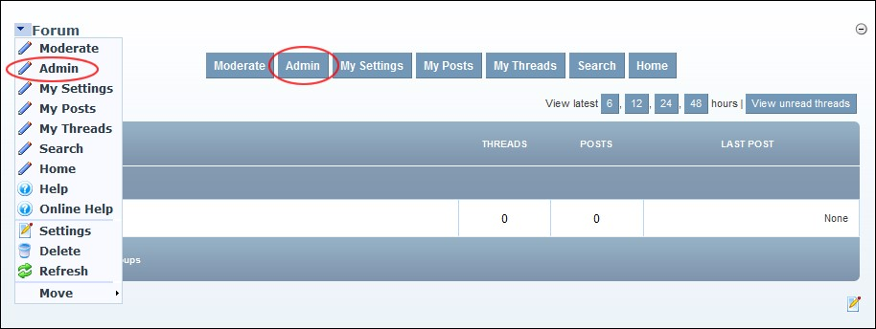

Navigating to the Forum Administration Page

## Control Panel Section

### Configuring General Forum Settings

How to configure the general settings of the Forums module such as the forum name and enable other basic settings.

1. Go to the Forum Administration page. See "Navigating to the Forum Admin Page"
2. In the left-hand panel, select **Control Panel** > **General**. This displays the General Configuration window.
3. At **Aggregated Forums**, mark  the check box to enable an aggregated view of threads inn all public forums - OR - unmark  the check box to disable.
4. At **Enable Thread Status**, mark  the check box to enable users to set the status of any posts they began - OR - unmark  the check box to disable. If enabled, thread status can be set as Unresolved, Resolved or Informative. Setting thread status is optional.
5. At **Enable Post Abuse**, mark  the check box to enable user to report any post to moderators and/or Administrators - OR - unmark  the check box to disable.
6. At **Disable HTML Posting**, mark  the check box to use a plain text box to enter posts - OR - unmark  the check box to use the Rich Text Editor and enable HTML posts.
7. At **Date Last Indexed**, the date and time when the Forum content was last indexed (added to DNN search) is displayed. To re-index forum content click the Reset link. This will re-index all forum content again and the new date will be displayed. Depending on how busy your Forum is you may choose to perform indexing weekly, fortnightly or monthly.
8. Click the **Update** button.

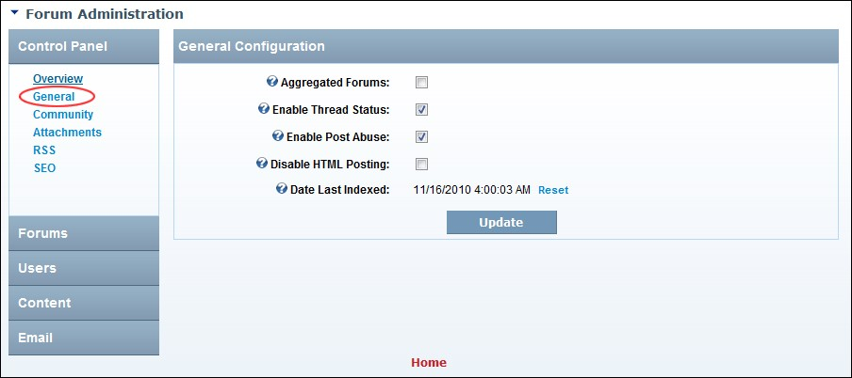

General Configuration Settings for the Forum

### Configuring the Forum Community Management Settings

How to enable the use of an external non-core module to display profile information. Note: This is not necessary for most installs.

1. Go to the Forum Administration page. See "Navigating to the Forum Admin Page"
2. In the left-hand panel, select **Control Panel** > **Community**. This displays the Community Management window.
3. At **Enable External Profile**, mark  the check box to enable use of a non-core module for user profiles. This exposes additional settings - OR - unmark  the check box to disable external profile and skip to Step 8.
4. At **Profile Page**, select the page that contains your profile module.
5. In the **Profile User Parameter** text box, enter the URL parameter associated with the User ID necessary for user profiles. This parameter is required by the non-core module.
6. In the **Profile Parameter Name** text box, enter the extra URL property for the non-core module.

The URL parameter name will be passed in combination with the value for external profile pages.

1. In the **Profile Parameter Value** text box, enter a value to be passed in combination with Parameter Name for the non-core module.
2. Click the **Update** button.

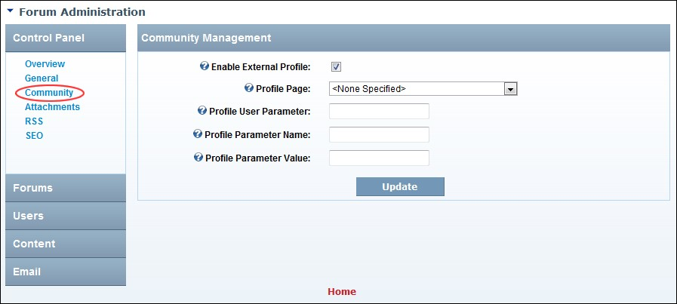

Forum Community Management Settings

### Configuring the Forum Search Engine Optimization

How to configure Search Engine Optimization (SEO) settings on the Forum module.

1. Go to the Forum Administration page. See "Navigating to the Forum Admin Page"
2. In the left-hand panel, select **Control Panel** > **SEO**. This displays the SEO Management window.
3. At **User's Website No Follow**, mark  the check box to indicate to search engines that links entered in user posts should be indexed as part of this website - OR - unmark  the check box to indicate that search engines should index these links as relevant to the site content and ranking.

This option relates to both user posts and user profile.

1. At **Override Page Title**, mark  the check box to override the page name with the forum name or thread name - OR - unmark  the check box to disable.
2. At **Override Page Description**, mark  the check box to override the page description - OR - unmark  the check box to disable.
3. At **Override Keywords**, mark  the check box to override the page keywords with ones pulled from within the module - OR - unmark  the check box to disable.
4. At **Latest Threads No Follow**, mark  the check box to indicate that the destination hyperlinks in the initial group view SHOULD NOT be afforded any additional weight or ranking by user agents which perform link analysis upon web pages (E.g. search engines). Note: This applies to the links in initial group view (6,12,24,48, view latest threads) typically seen when first viewing a page with the forum module placed on it - OR - unmark  the check box to disable.
5. In the **Sitemap Priority** text box, enter the SEO Sitemap priority per thread (this number must be between 0.0 and 1.0). The default is0.5. Note: This will only be enabled if the Forum SEO Sitemap provider is installed.
6. Click the **Update** button.

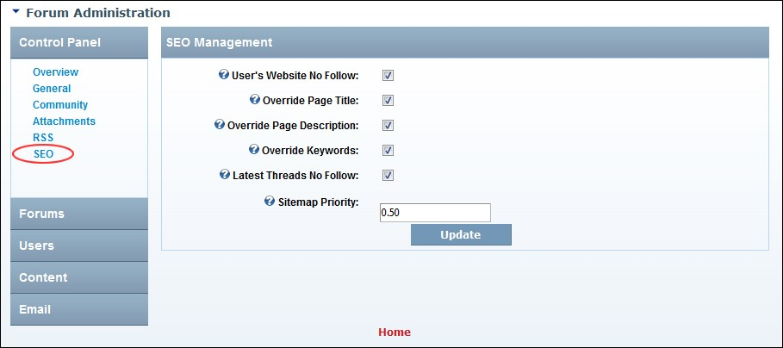

Configuring the Forum Search Engine Optimization Settings

### Enabling/Disabling Attachments

How to enable or disable the attaching of files to forum posts, as well as configure additional attachment settings on the Forums module.

1. Go to the Forum Administration page. See "Navigating to the Forum Admin Page"
2. In the left-hand panel, select **Control Panel** > **Attachments**. This displays the Attachment Management window.
3. At **Enable File Attachment**, mark  the check box to enable attachments- OR - unmark  the check box to disable file attachment and skip to Step 7.
4. At **Anonymous Downloads**, mark  the check box to enable files to be downloaded by unauthorized users - OR - unmark  the check box to disable. Note: File permissions also control access to files.
5. In the **Attachments Path** text box, edit the location where attachments are stored in the root directory of this site’s File Management. I.e. domain.com../../../../../Resources/
6. In the **Max Attachment Size** text box, edit the maximum size for attachments in KB. Note: Additionally, the size set here should be no larger than what is permitted in the web.config.
7. Click the **Update** button.

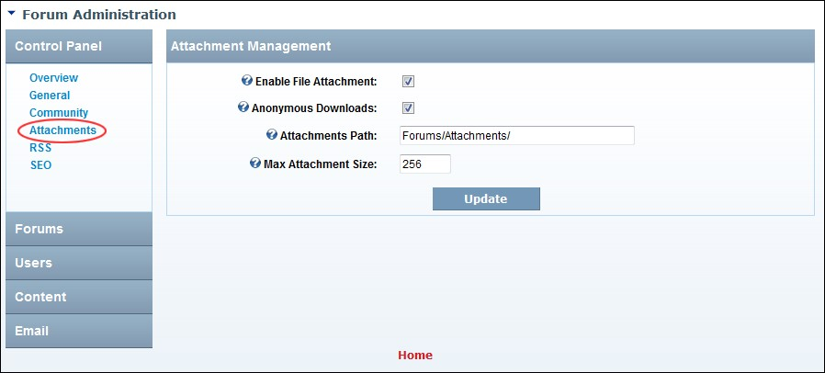

Managing Forum Post Attachments

### Managing RSS Feeds

How to enable or disable an RSS Feed being created for all public forums, as well as configure related settings.

1. Go to the Forum Administration page. See "Navigating to the Forum Admin Page"
2. In the left-hand panel, select **Control Panel** > **RSS**. This displays the RSS Management window.
3. At **Enable RSS Feeds**, mark  the check box to enable RSS feeds for all public forums - OR - unmark  the check box to disable and skip to Step 6.
4. In the **Threads Per Feed** text box, enter the number of post threads to be displayed in the feed. The default value is 20 threads.
5. In the **Time To Live** text box, enter the frequency in minutes that the RSS is cached before refreshing. The default value is 30 minutes.
6. Click the **Update** button.

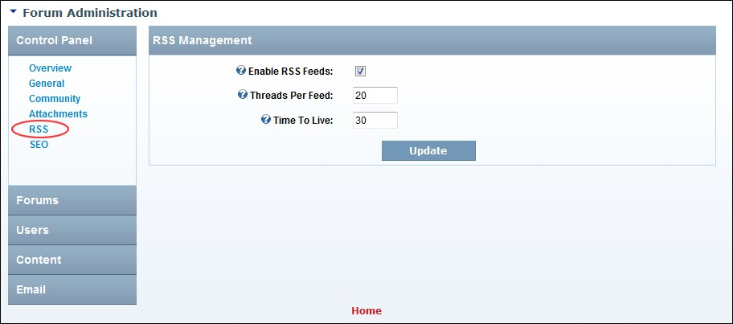

Manage RSS Feeds for Forums

## Content Section

### Adding a Filtered Word

How to filter any content such as words, phrases and numbers from Forum posts. You can choose to either remove the content from the post or replacing it with an alternate word, phrase or number.

1. Go to the Forum Administration page. See "Navigating to the Forum Admin Page"
2. In the left-hand panel, select **Content** > **Filter Words**. This displays the Filtered Word Management window.
3. In the **Filter** text box, enter the content to be filtered.
4. In the **Replacement** text box, enter the replacement content - OR - Leave blank to remove the filter word without replacing it.

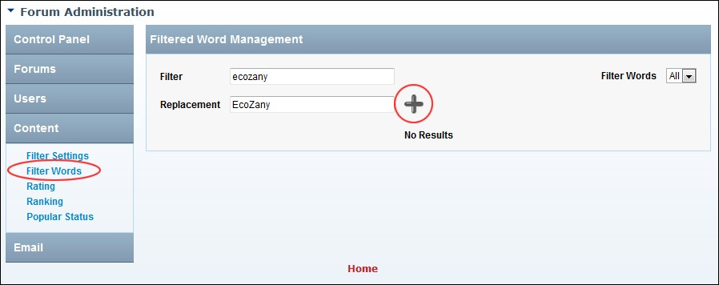5. Click the **Add button** on this page.

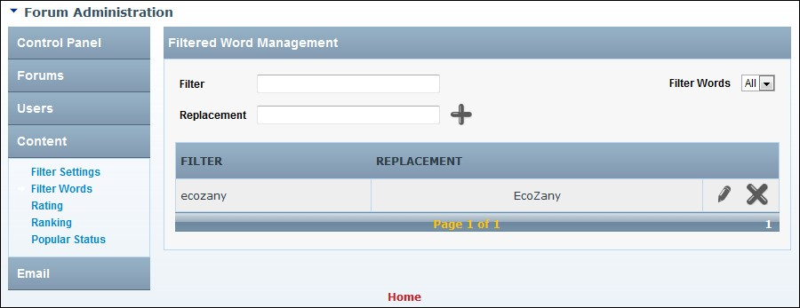

### Deleting a Filtered Word

How to delete a filtered word from the Forum module.

1. Go to the Forum Administration page. See "Navigating to the Forum Admin Page"
2. In the left-hand panel, select **Content** > **Filter Words**. This displays the Filtered Word Management window.
3. In the **Filter** column, locate the word to be deleted. See "Filtering Filter Words"
4. Click the **Delete**  button and then click the **OK** button to confirm.

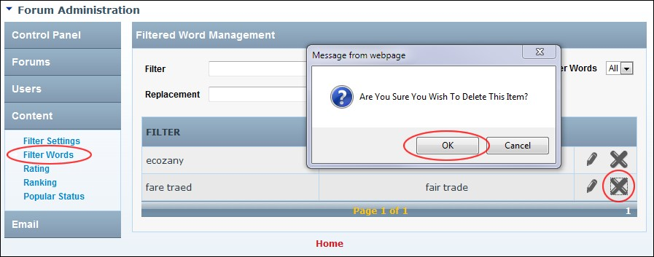

Deleting a Filtered Word

### Editing Filtered Words

How to edit a filtered word and/or its replacement word in the Forum module.

1. Go to the Forum Administration page. See "Navigating to the Forum Admin Page"
2. In the left-hand panel, select **Content** > **Filter Words**. This displays the Filtered Word Management window.
3. In the **Filter** column, locate the filtered word to be edited. See "Filtering Filter Words"
4. Click the **Edit**  button.

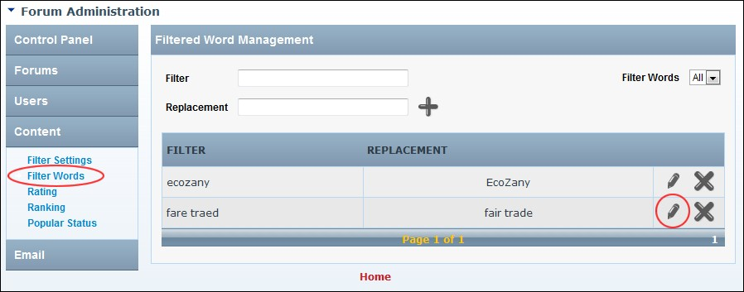

1. Edit the **Filter** and/or the optional **Replacement** word as required.
2. Click the **Update** button.

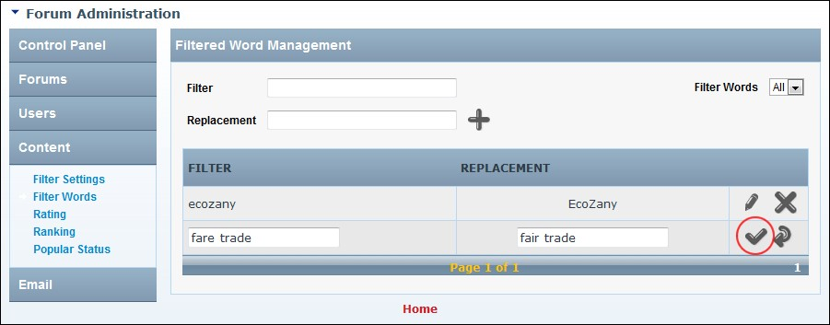

Editing Filtered Words

### Enabling/Disabling Word Filtering

How to enable or disable the filtering of words in the body of posts, including an option to also filter the subject of posts.

1. Go to the Forum Administration page. See "Navigating to the Forum Admin Page"
2. In the left-hand panel, select **Content** > **Filter Settings**. This displays the Filter Management window.
3. At **Enable Word Filter**, mark  the check box to enable word filtering in post body - OR - unmark  the check box to disable. If this option is unchecked, skip to Step 5.
4. At **Filter Subjects**, mark  the check box to enable word filtering in the subject of posts - OR unmark  the check box to disable.
5. Click the **Update** button.

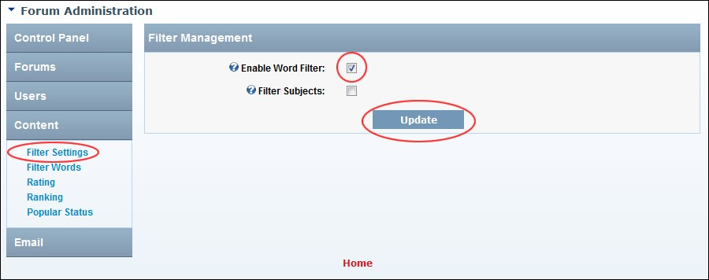

Enabling Word Filtering

### Filtering Filter Words

How to view all filtered words or filter them by the first letter of the filtered word for the Forum module.

1. Go to the Forum Administration page. See "Navigating to the Forum Admin Page"
2. In the left-hand panel, select **Content** > **Filter Words**. This displays the Filtered Word Management window.
3. At the **Filter Words** drop down list, select **All** to view all words - OR - Select the first letter of the filtered word. This displays matching results in alphabetical order. Note: Use the linked page numbers to navigate to words displayed on another page.

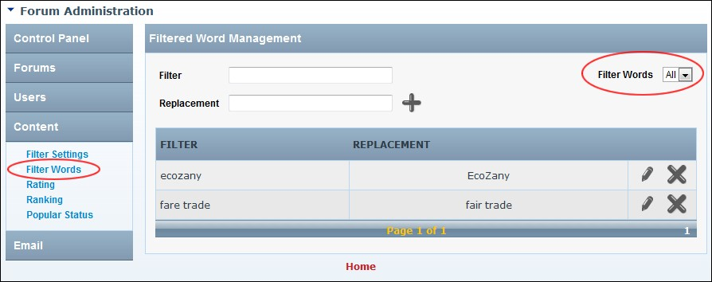

Filtering Filtered Words

Tip: The filter will continue to be applied until you either click the All link or navigate to another section and then return to the Filtered Word Management section.

### Managing Forum User Ranking

How to enable or disable ranking of forum users and set the number of posts required to achieve ranking positions in the Forum module. If enabled, the ranking images will display in the user posts avatar area.

1. Go to the Forum Administration page. See "Navigating to the Forum Admin Page"
2. In the left-hand panel, select **Content** > **Ranking**. This displays the Ranking Management window.
3. At **Enable**, mark  the check box to enable ranking - OR - unmark  the check box to disable.
4. At **Enable Images**, mark  the check box to display ranking as images- OR - unmark  the check box to display ranking as text. If this option is checked then the images displayed on this page will be used.
5. At **1st Rank** complete the following:
   1. In the **Count** text box (left), edit the number of posts required for a poster to rank as 1st.
   2. In the **Title** text box (right), enter/edit a title to be displayed for this level of ranking. If the field is left blank then the title of "1st Level Poster" is displayed. Note: If the **Enable Images** check box is marked  then this option is not used.
6. Repeat Steps 5 to manage 2nd-10th ranking fields.
7. **Optional.** In the **No Ranking** text box, enter a title to be displayed for users without any ranking. Note: If the Enable Images check box above is checked, then this option is not used.
8. Click the **Update** button.

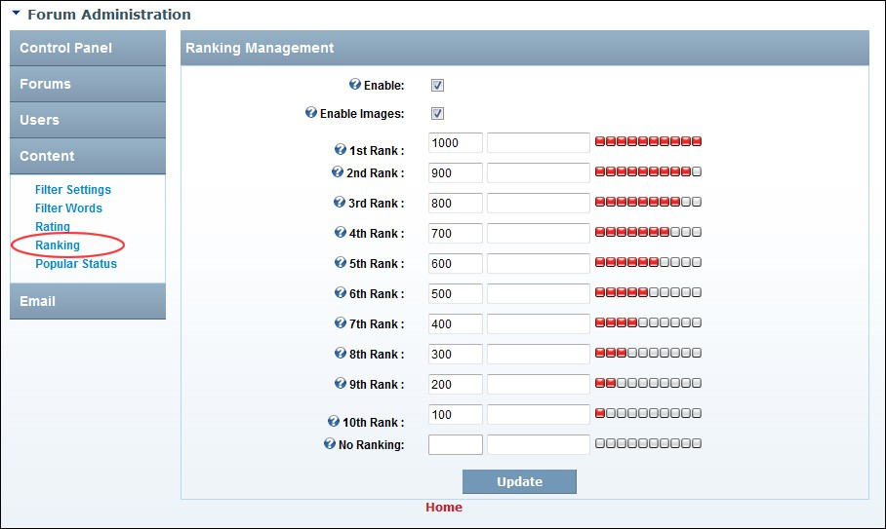

Configuring Post Ranking Settings

### Managing Popular Thread Status

How to set the number of times a thread must be viewed and replied to be marked as a popular thread in the Forum module.

1. Go to the Forum Administration page. See "Navigating to the Forum Admin Page"
2. In the left-hand panel, select **Content** > **Popular Status**. This displays the Popular Status Management window.
3. In the **View Count** text box, enter the number of views required before a thread is marked as popular - OR - leave blank if the number of views is not taken into account. The default setting is 200.
4. In the **Reply Count** text box, enter the number of replies required before a thread is marked as popular - OR - leave blank if the number of replies not taken into account. The default setting is 10.
5. In the **Active Within** text box, enter the number of days since the last post for a thread to be marked as popular. The default setting is 7.
6. Click the **Update** button.

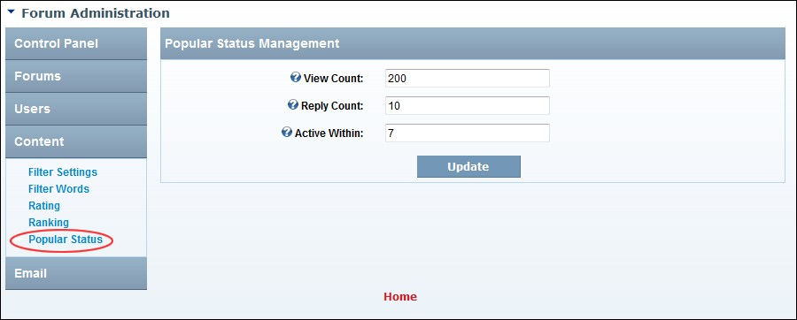

Managing Popular Thread Status

### Managing Rating of Threads

How to enable or disable the users to rate threads and optionally replace the star  icon(s) with text. Note: Rating must be enabled on individual forums. See "Setting Forum Options"

1. Go to the Forum Administration page. See "Navigating to the Forum Admin Page"
2. In the left-hand panel, select **Content** > **Rating**. This displays the Rating Management window.
3. At **Enable**, mark  the check box to enable users to rate a thread - OR - unmark  the check box to disable.
4. In the **Rating Scale** text box, enter a number that represents the highest rating for a thread. This sets the maximum number of stars. The default is 5. Note: Changing this will not update existing post ratings.
5. Click the **Update** button.

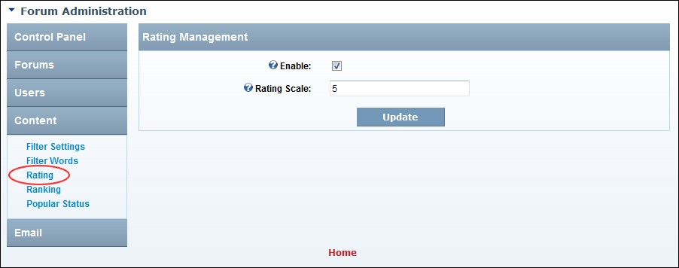

Enabling Thread Rating and Setting Maximum Number of Stars

## Email Section

### Managing Email Settings

How to enable or disable email notifications for the Forum module as well as configure notification settings.

1. Go to the Forum Administration page. See "Navigating to the Forum Admin Page"
2. In the right-hand panel, select **Email** > **Email Settings**. This displays the Email Management section.
3. In the **From Address** text box, enter the from email address for all outgoing forum emails.
4. In the **Email Display Name** text box, enter the friendly name to be used for outgoing email notifications from this forum.
5. At **Email Notifications**, mark  the check box to enable email notification for this module. This displays3 additional settings - OR - unmark  the check box to disable. If unchecked, skip to Step 9.
6. At **Enable From Address Per Forum**, mark  the check box to enable the From address to be set on individual forums. See "Setting Forum Email" - OR - unmark  the check box to disable and use the address set in Step 3 above for all forums.
7. At **Enable Edit Emails**, mark  the check box to send a notification email to users when posts are edited - OR - unmark  the check box to disable.
8. At **Enable Email Queue**, mark  the check box to send notifications using the schedule - OR - unmark  the check box this feature is disabled.
9. Click the **Update** button.

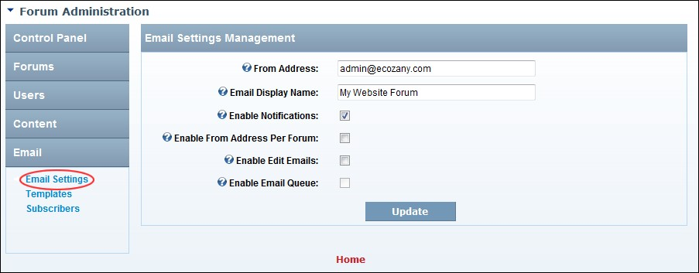

Managing email notifications from the Forum module

### Managing Email Templates

How to modify the subject and body of the email notifications sent from the Forum module.

1. Go to the Forum Administration page. See "Navigating to the Forum Admin Page"
2. In the left-hand panel, select **Email** > **Templates**. This displays the Email Template Management window.
3. At **Email Template**, select the template to be edited.
4. In the **Email Subject** text box, edit the name of the email subject.
5. In the **HTML Email Body** text box, edit the HTML version of the email.
6. In the **Text Email Body** text box, edit the text version of the email.
7. Click the **Update** button.

Note: The following replacement tokens are available to use in the subject and body of emails:

**[FORUMNAME]** Name of the forum

**[POSTSUBJECT]** Subject of the post

**[DATEPOSTED]** Date of the post

**[POSTAUTHOR]** Post Author

**[POSTBODY]** Post Body

**[POSTURL]** URL to view the post

**[GROUPNAME]** Name of forum group

**[PROFILELINK]** Link to user’s profile

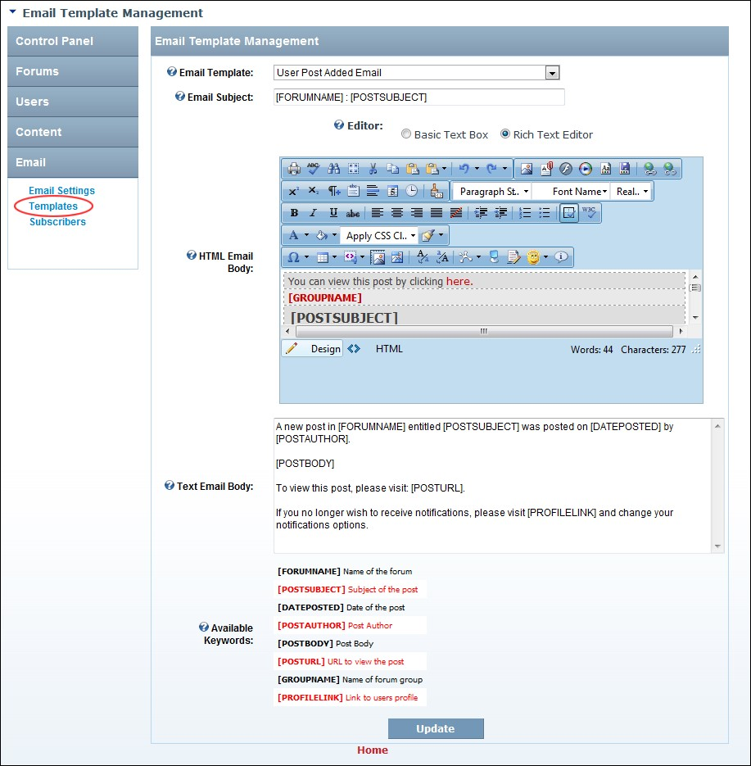

Managing Email Notification Templates

### Viewing Email Subscribers Report

How to view the email subscriber report for the Forum module.

1. Go to the Forum Administration page. See "Navigating to the Forum Admin Page"
2. In the left-hand panel, select **Email** > **Subscribers**. This displays the Email Subscribers Report window.
3. Select a report type for the drop down list. This displays details in the table below.

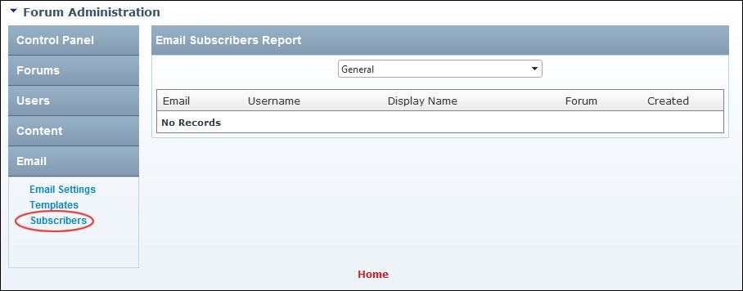

Viewing Email Subscribers Report

## Forums Section

### Adding a Forum Group

How to add a new forum group to the Forum module. A forum group is like a category which enable you to organize forums into one or more groups. Users cannot actually post to a forum group, but rather to the forums within that group. Once you have created a forum group, one or more forums must be added to it. A forum group called Discussions which contains a forum called General is created by default.

1. Go to the Forum Administration page. See "Navigating to the Forum Admin Page"
2. In the left-hand panel, select **Forums** > **Forum Manager**. This displays the Forum and Group Management window.
3. In the **Group Name** text box, enter a name for the forum group.
4. Click the **Add**  button.

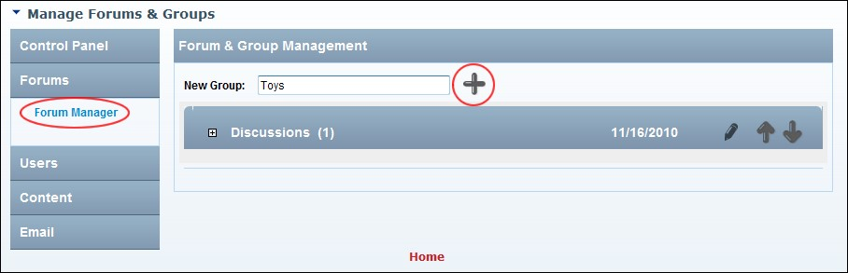

Adding a Forum Group

### Adding a Forum

How to add a new forum to the Forum module.

1. Go to the Forum Administration page. See "Navigating to the Forum Admin Page"
2. In the left-hand panel, select **Forums** > **Forum Manager**. This displays the Forum and Group Management section.
3. **Maximize**  the **Forum Group** to which the forum will be added.

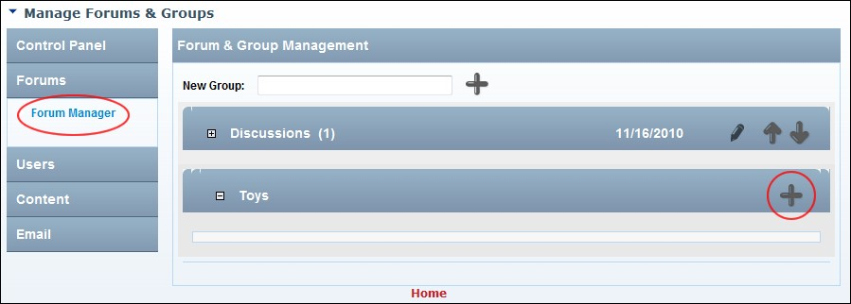

4.

Click

the

**Add**

**Forum**



button

located

in

the

title

bar

of

the

selected

group.

This

displays

the

General Settings tab of the Edit Forum window.

1. At **Forum is Enabled**, mark  the check box if the forum to be displayed and allowing posting - OR - unmark  the check box if the forum is disabled.
2. **Optional.** At **Group**, re-select the Forum Group if required. The group selected at step 3 will be pre-selected.
3. **Optional.** At **Parent Forum**, select a parent for this forum.
4. In the **Forum Name** text box, enter a name for the new forum.
5. **Optional.** In the **Description** text box, enter a short description of the purpose of this forum and the intended content.
6. **Optional.** See "Setting Forum Permissions", See "Setting Forum Options" or See "Setting Forum Email"

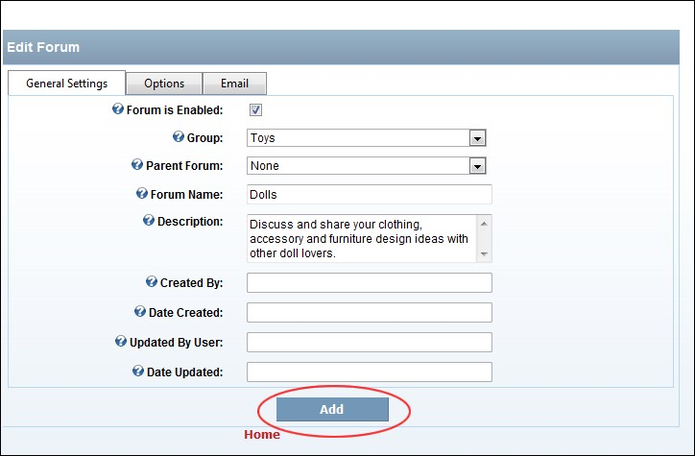

1. Click the Add link. The new forum is now added to the selected group.
2. **Optional. Maximize**  the **Forum Group** to view the new forum.

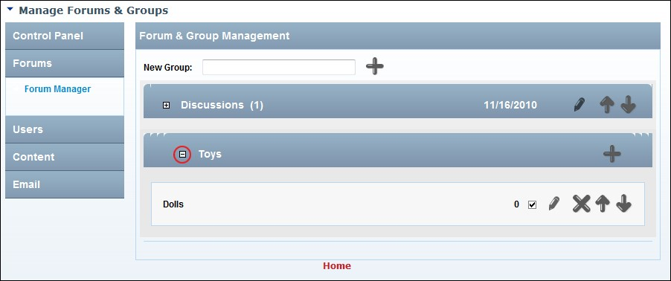

The Newly Added Forum

Note: The Created By, Date Created, Updated By User and Date Updated fields on the Edit Forum page are automatically populated when the forum is added.

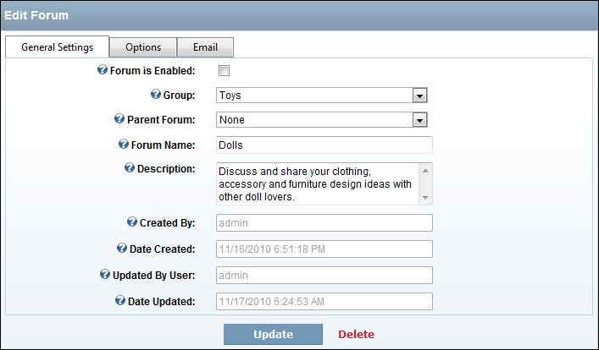

Details of the Newly Added Forum on the Edit Forum page

### Deleting a Forum Group

How to permanently delete a forum group, including all related forums and posts.

1. Go to the Forum Administration page. See "Navigating to the Forum Admin Page"
2. In the left-hand panel, select **Forums** > **Forum Manager**. This displays the Forum and Group Management window.
3. Ensure the Forum Group is minimized  as this exposes the **Delete** button.
4. Click the **Delete**  button and then click the **OK** button to confirm.

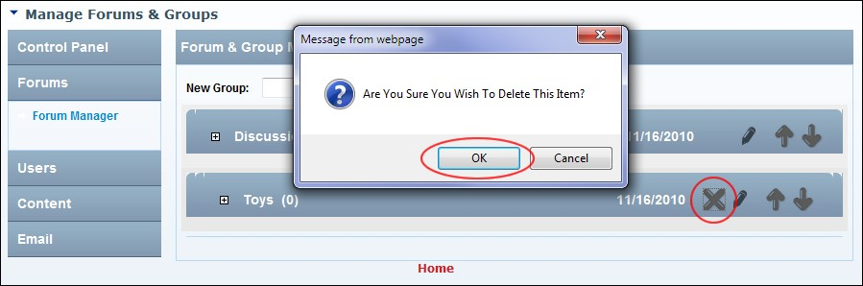

Deleting a Forum Group

### Deleting a Forum

How to permanently delete a forum and all posts within that Forum using the Forums module.

1. Go to the Forum Administration page. See "Navigating to the Forum Admin Page"

2. Select **Forums** > **Forum Manager**. This displays the Forum and Group Management section.

1. **Maximize**  the **Forum Group** associated with the forum to be deleted.
2. Click the **Delete**  button and then click the **OK** button to confirm.

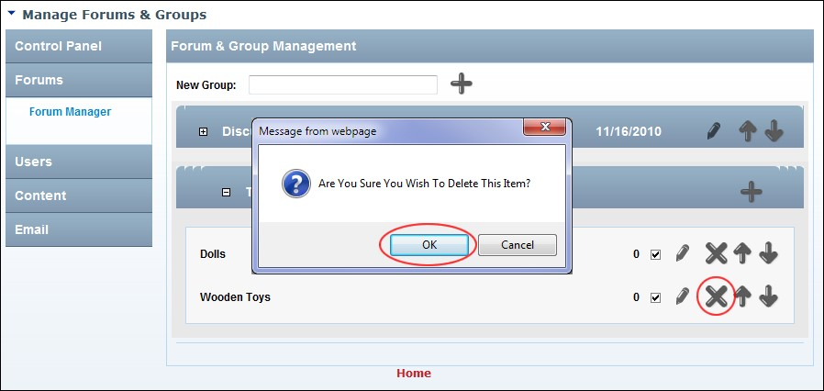

Deleting a Forum

### Editing a Forum Group

How to edit the name of a forum group.

1. Go to the Forum Administration page. See "Navigating to the Forum Admin Page"
2. In the left-hand panel, select **Forums** > **Forum Manager**. This displays the Forum and Group Management window.
3. Click the Edit Group button beside the required forum group.
4. Edit the forum group name in the exposed text box.
5. Click the **Update** button.

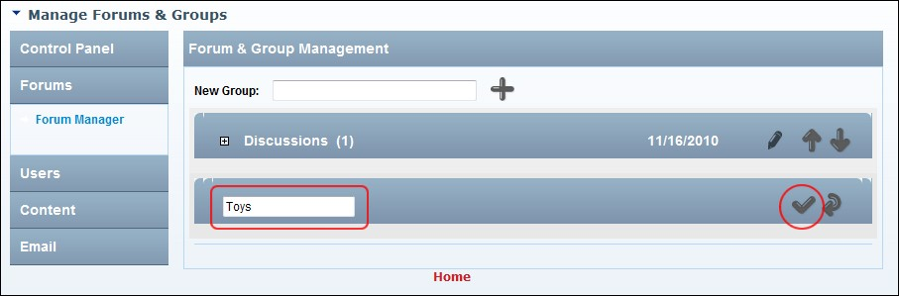

Editing a Forum Group

### Editing a Forum

How to edit the name or settings of a forum.

1. Go to the Forum Administration page. See "Navigating to the Forum Admin Page"
2. In the left-hand panel, select **Forums** > **Forum Manager**. This displays the Forum and Group Management window.
3. **Maximize**  the **Forum Group** associated with the forum to be edited.
4. Click the **Edit Forum**  button beside the required forum.
5. Edit any general settings (See "Adding a Forum"), forum options (See "Setting Forum Options" and See "Setting Forum Permissions") or forum email settings (See "Setting Forum Email") as required.
6. Click the **Update** button.

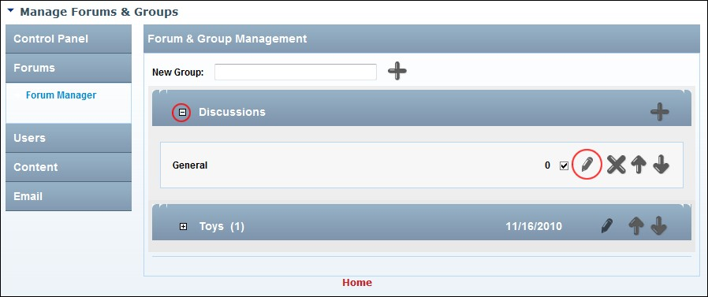

Editing a Forum

### Enabling/Disabling a Forum

How to enable or disable a forum. Enabled forums are open for viewing to all those who can see it and posting for all those who are permitted to post to it. Disabled forums cannot be viewed and posted to.

1. Complete Steps 1-4 of "Editing a Forum" tutorial to access the Edit Forum page.
2. At **Forum is Enabled**, mark  the check box to enable this forum - OR - unmark  the check box to disable it.
3. Click the **Update** button.

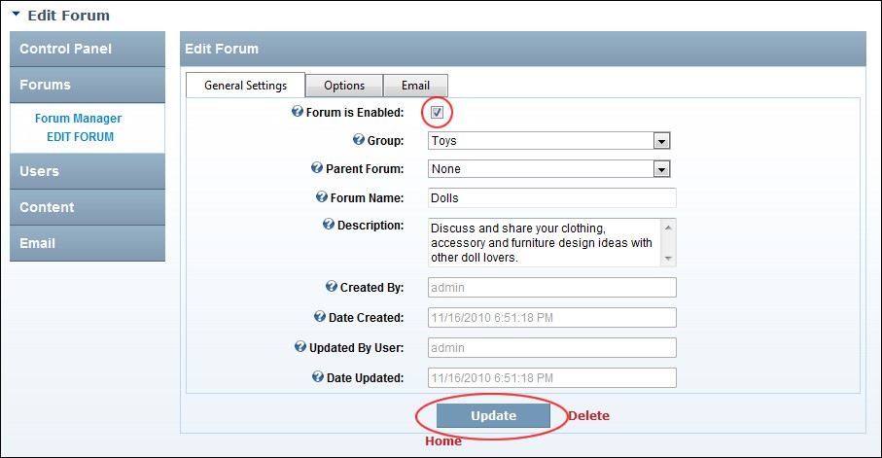

Enabling or disabling a forum

### Loading Existing Forum Permissions

How to load permissions from an existing forum to another forum using the Forum module. These permissions can then be edited if required.

1. Complete Steps 1-4 of "Editing a Forum". This will take you to the Edit Forum page.
2. Select the **Options** tab.
3. At **Load Permissions of Forum**, select the forum you wish to load permissions from. This displays the permissions of the selected forum in the permissions grid above. If these permissions match the permissions you want for this forum, then skip to Step 7. Alternatively, complete the remaining steps to customize these permissions for this forum.
4. **Optional.** In the **User** text box, enter the username of a user that you want to grant or deny module permissions for, and then click the  Add link. Repeat for additional usernames.
5. **Optional.** At **Filter By Group**, select from the following options:

* **<All Roles >**: Select to view all roles (both global and group roles) in one single list.
* **< Global Roles >**: Select to view all roles which are not associated with a Role Group. This includes Administrators, All Users, Registered Users, and Unauthenticated Users.
* **[Role Name]**: Select the name of a Role Group to view the roles within that group.

1. For each permission type (listed below), mark  the check box beside each role to grant that permission - OR - unmark  the check box to deny that permission. Note: Some options maybe disabled depending Forum Type of this forum.
   * **View**: Select all roles that can view this forum.
   * **Start**: Select all roles that can begin a new thread in this forum.
   * **Reply**: Select all roles that can reply to a post in this forum.
   * **Moderate**: Select all roles that can moderate on this forum. Administrators are enabled by default.
   * **Attach**: Select all roles that can add an attachment to their posts for this forum. Administrators are enabled by default.
   * **Pin**: Select all roles that can pin a thread on this forum. Pinned threads will appear at above other threads. Administrators are enabled by default.
   * **Lock**: Select all roles that can lock thread on this forum. Replies cannot be made to locked threads.
   * **Notify**: Select all roles that to receive moderator notification from this forum.
   * **Unmoderated**: Select all roles that do not require moderation.
2. Click the **Update** button.

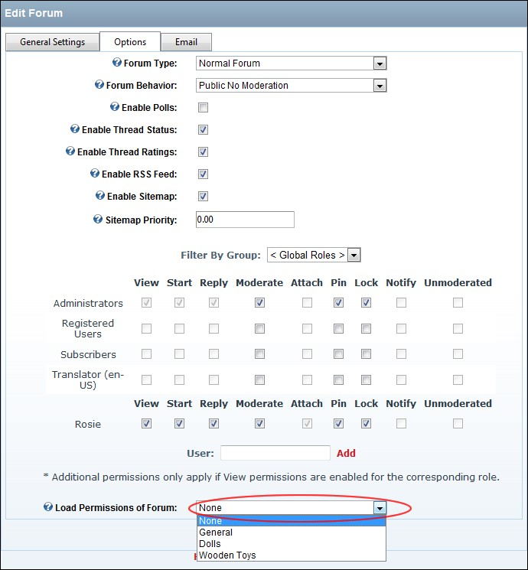

Loading Existing Forum Permissions

### Re-Ordering Forum Groups

How to modify the view order of forum groups on the Forum module.

1. Go to the Forum Administration page. See "Navigating to the Forum Admin Page"
2. In the left-hand panel, select **Forums** > **Forum Manager**. This displays the Forum and Group Management window.
3. Click the **Move Up**  or **Move Down** button on beside a forum group to move it up or down one position respectively.

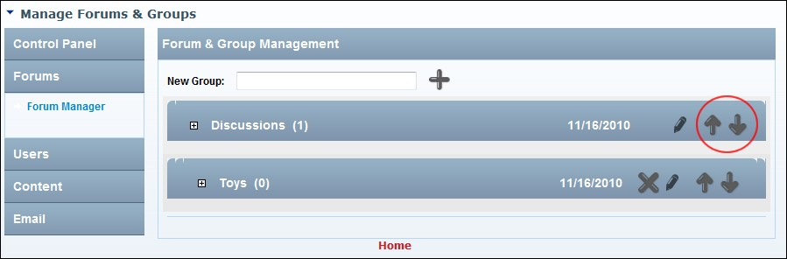

Reordering Forum Groups

### Re-ordering Forums

How to modify the order of forums within a forum group using the Forum module.

1. Go to the Forum Administration page. See "Navigating to the Forum Admin Page"
2. In the left-hand panel, select **Forums** > **Forum Manager**. This displays the Forum and Group Management window.
3. **Maximize**  the **Forum Group** associated with the forum to be edited.
4. Click the **Move Up**  or **Move Down** button beside a forum to move it up or down one position respectively.
5. Repeat Steps 3-4 to re-order forums within another forum group.

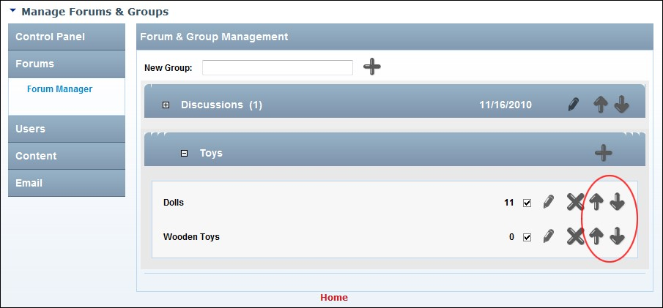

Reordering Forums

### Setting Forum Email

How to configure the email settings for individual forums. Note: Only the "From" email address and display name are used at this time. Note: The “Enable Form Address Per Forum” field must be enabled to access this page. See "Managing Email Settings"

1. Complete Steps 1-4 of editing a forum. See “Editing a Forum"
2. Select the **Email** tab.
3. On the Edit Forum page, click on the Email link and complete these optional settings:
4. In the **Forum "From" Email Address** text box, edit the email address that will be displayed for all outgoing emails for this particular forum.
5. In the **Email Display Name** text box, enter the friendly display name used on outgoing emails sent from this forum.
6. Click the **Update** button.

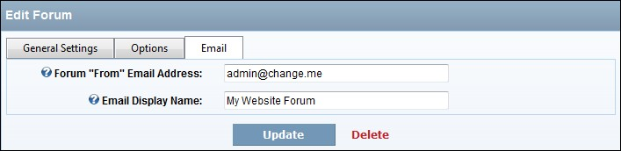

Setting Forum Options

### Setting Forum Options

How to configure the optional settings for individual forums. This tutorial assumes you are in the process of adding a new forum or editing an existing forum.

1. Complete Steps 1-4 of  “Editing a Forum". This will take you to the Edit Forum page.
2. Select the **Options** tab.
3. At **Forum Type**, select from the following options:
   * **Normal**: This is the usual option for a forum.
   * **Notification**: This option is the same as a normal forum however all forum users will receive notification of new posts and are unable to unsubscribe from notifications.
   * **Link**: This option redirect user to designated link and can be used to redirect users to old or disabled forums. If this option is selected a field called Forum Link will be displayed where you can select the URL link.
4. At **Forum Behavior**, select from the following options which will modify the available options when setting role permissions below:
   * **Public Moderation**: A public moderated forum that is available to everyone who can view the module.
   * **Public Moderation w/Post Restrictions**: A public moderated forum that enables everyone who can view the module to view posts, but only authorized users to add post.
   * **Public No Moderation**: A public un-moderated forum which enables everyone who can view the module to view and add posts.
   * **Public No Moderation w/Post Restrictions**: A public unmoderated forum that enables everyone who can view the module to view posts, but only authorized users to add post.
   * **Private Moderation**: A private moderated forum that is available to everyone who can view the module.
   * **Private Moderation w/Post Restrictions**: A private moderated forum that enables everyone who can view the module to view posts, but only authorized users to add post.
   * **Private No Moderation**: A private unmoderated forum which enables everyone who can view the module to view and add posts.
   * **Private No Moderation w/Post Restrictions**: A private unmoderated forum that enables everyone who can view the module to view posts, but only authorized users to add post.
5. At **Enable Polls**, mark  the check box to enable users who can begin a thread to attach a poll which other users to participant in - OR - unmark  the check box to disable.
6. At **Enable Thread Status**, mark  the check box to enable users to change the status of a thread - OR – unmark  the check box to disable. See "Managing Popular Thread Status"
7. At **Enable Thread Ratings**, mark  the check box to enable users to rate threads - OR - unmark  the check box to disable. See "Managing Rating of Threads"
8. At **Enable RSS Feed**, mark  the check box to enable users to view an RSS feed for the specified forum (as long as it isn't Private) - OR - unmark  the check box to disable.
9. At **Enable Sitemap**, mark  the check box to enable threads created within this forum will be exposed to the SEO Sitemap provider (as long as it isn't Private) - OR - unmark  the check box to disable.
10. In the **Site Map Priority** text box, enter a number between 0.1- 1.0 that is used to determine the SEO Sitemap priority. This requires changes to your web.config, where you can add the forum SEO Sitemap provider manually.
11. Click the **Update** button.



Setting Forum Options

### Setting Forum Permissions

How to set unique permissions for individual Forums within the Forum module.

1. Complete Steps1-4 of “Editing a Forum". This will take you to the Edit Forum page.
2. Select the **Options** tab.
3. Go to the Permissions grid.
4. **Optional.** In the **User** text box, enter the username of a user that you want to grant or deny module permissions for, and then click the  Add link. Repeat for additional usernames. **Optional.** At **Filter By Group**, select from the following options: **All Roles**: Select to view all roles (both global and group roles) in one single list. **Global Roles**: Select to view all roles which are not associated with a Role Group. This includes Administrators, All Users, Registered Users, and Unauthenticated Users. **[Role Name]**: Select the name of a Role Group to view the roles within that group.
5. For each permission type (listed below), mark  the check box beside each role to grant that permission - OR - unmark  the check box to deny that permission. Note: Some options maybe disabled depending Forum Type of this forum.
   * **View**: Select all roles that can view this forum.
   * **Start**: Select all roles that can begin a new thread in this forum.
   * **Reply**: Select all roles that can reply to a post in this forum.
   * **Moderate**: Select all roles that can moderate on this forum. Administrators are enabled by default.
   * **Attach**: Select all roles that can add an attachment to their posts for this forum. Note: Users/Roles must be granted permission to add files (See "Modifying Folder Permissions" in the DNN Platform Administrators User Manual) to the attachments folder located with Admin > File Management. This is typically the PortalRoot/Forums/Attachments folder, unless set otherwise (See "Enabling/Disabling Attachments". Administrators are enabled by default.
   * **Pin**: Select all roles that can pin a thread on this forum. Pinned threads will appear at above other threads. Administrators are enabled by default.
   * **Lock**: Select all roles that can lock thread on this forum. Replies cannot be made to locked threads.
   * **Notify**: Select all roles that to receive moderator notification from this forum.
   * **Unmoderated**: Select all roles that do not require moderation.
6. To set permissions for an individual, enter their username into the Username text box and click the Add link to the right of the text box. You must then complete role permissions as for Step 2.
7. To set permissions based on the permissions selected on another forum, select the forum name from the **Load Permissions of Forum** drop down list. You can now edit these permission as shown at Step 2.
8. Click the Add link.

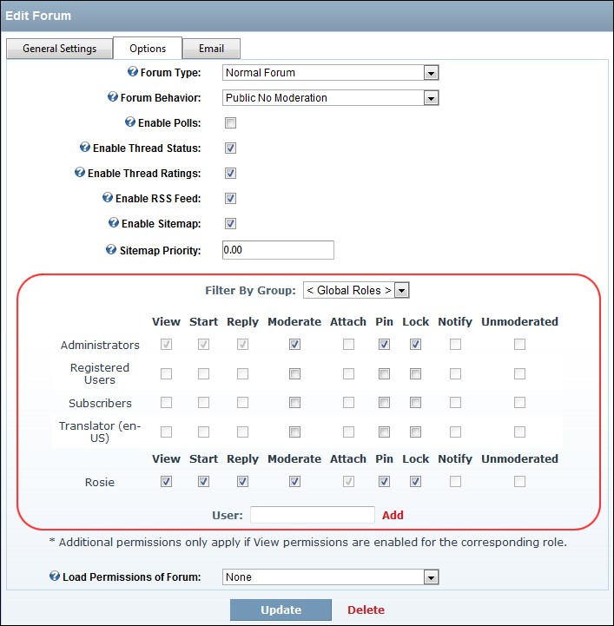

Setting Forum Permissions

## Users Section

### Configuring System Avatars

How to enable systems avatars on the Forum module and configure the related settings.

1. Go to the Forum Administration page. See "Navigating to the Forum Admin Page"
2. In the left-hand panel, select **Users** > **Avatars**. This displays the Avatar Management window.
3. At **Enable User Avatars**, unmark  the check box to use system avatars.
4. In the **User Image Size Limit** text box, enter the maximum upload size in KB for the avatar image. The default setting is 64.
5. At **Enable Avatar Pool**, mark  the check box to upload a folder of avatar images that users can choose from and optionally modify the folder where the Pool Avatars are stored by changing the path inside the **Pool Avatar Path** text box - OR - unmark  the check box to disable.
6. At **Enable System Avatars**, mark  the check box to Site Administrators and Forum Administrators to assign avatar images to specific users of their choice. This is done per user, not by role. **In The System Avatar Path** text box, modify the folder where the System Avatars are stored if required. Note: Forum Administrators must be given permission to view this folder - OR - unmark  the check box to disable.
7. At **Enable Role Avatars**, mark  the check box to assign avatar images based on role. In the **In the Role Avatar Path** text box modify the folder where the Role Avatars are stored if required. - OR - unmark  the check box to disable.
8. Click the **Update** button.

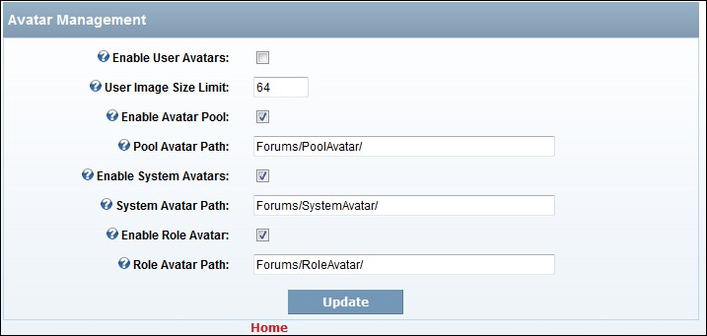

Configuring System Avatars

### Configuring the Default Forum User Interface

How to configure the default user interface setting for the Forum module.

1. Go to the Forum Administration page. See "Navigating to the Forum Admin Page"
2. In the left-hand panel, select **Users** > **User Interface**. This displays the User Interface Management window.
3. In the **Threads Per Page** text box, enter the number of threads to be displayed on one page at one time. The default setting is10. Note: Authenticated Users can override this setting for themselves on the My Settings page.
4. In the **Posts Per Page** text box, enter the number of posts to be displayed on one page at one time. The default setting is5. Note: Authenticated Users can override this setting for themselves on the My Settings page.
5. In the **Thread Page Count** text box, enter the number of the number of pages to show in threads view next to the thread subject. The default setting is3.
6. At **Theme**, select a theme to be used for this forum.
7. At **Theme Image Extension**, enter the extension of images used in the Theme. The default setting is png which relates to the Default theme.
8. At **Display Location**, select from the following options:

 **None**: Select to hide the country of the poster.

 **To Admin Users**: Select to display the country of the poster to Administrators only.

 **To All Users**: Select to display the country of the poster to all users.

1. At **Display Region**, mark  the check box to display the posters region - OR - unmark  the check box to hide.
2. At **Enable Quick Reply**, mark  the check box to enable users to post replies directly in posts view. This uses a normal text box and not a Rich Text Editor and is only visible to those with proper posting permissions - OR - unmark  the check box to disable.
3. At **Enable User Tagging**, mark  the check box to enable authenticated users to tag threads in public forums - OR - unmark  the check box to disable.
4. Click the **Update** button.

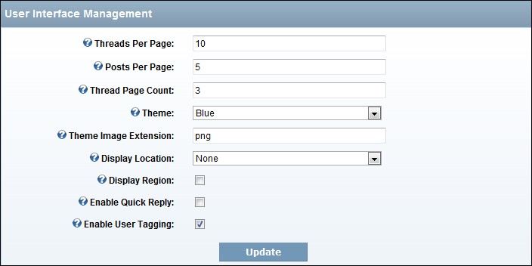

Setting the Forum User Interface

### Editing any Forum User's Profile

How to edit any forum user’s profile using the Forum module. Note: Field visibility is managed by the user on their DNN user profile. Forum users can manage their own profile under My Settings.

1. Search and located the required user. See "Searching Forum User Accounts"
2. Locate the required user and click the **Edit** button beside their username to display the Edit Profile page.

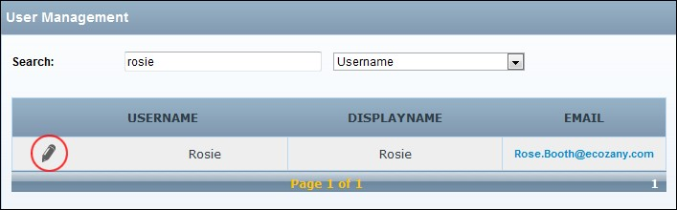

1. **Optional.** If this is the first time you have visited this user profile on this page, you can click the **Update** button and then Refresh (Ctrl + F5) the screen to view the user’s Username, Site Alias and Email Address details. Alternatively, they will be viewable whenever you update this page.
2. In the **User ID** text box, modify the user’s unique identifier.
3. At **Username**, here you can view the user's DNN username. Note: Users can click the link to edit their Account profile for this site.
4. At **Site Alias**, view the alias shown to other users of this module. This will either be the user's Display Name or Username, depending on module settings.
5. At **Email Address**, displays the user’s email address. In addition, a marked  check box displayed if other forum users can view this user's email address in the user profile screen.
6. At **Trusted User**, mark  the check box if the user's posts are not moderated - OR - unmark  the check box to enable moderation.
7. At **Lock Trust**, mark  the check box if the user's trust status can only be changed by module administrators- OR - unmark  the check box if all forum administrators can edit the Trusted User settings.
8. Click the **Update** button.

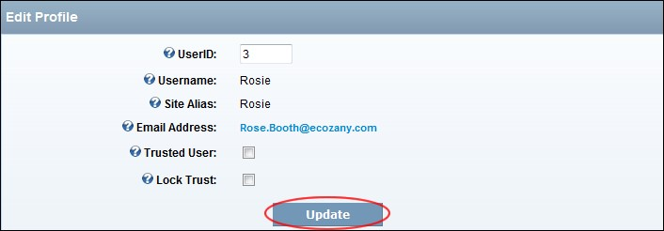

Viewing/Editing a Forum User's Profile

### Editing any Forum User's Signature

How to edit any Forum user's signature using the Forum module.

1. Search and located the required user. See "Searching Forum User Accounts"
2. Locate the required user and click the **Edit** button beside their username to display the Edit Profile page.
3. In the **Signature** text box, add/edit the user’s signature. Basic HTML formatting maybe disabled. See "Editing Global User Settings"
4. Click the Preview link to preview the signature if required and then click the Edit link to edit the signature.

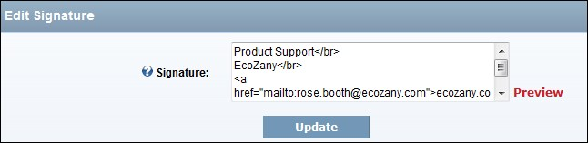

1. Click the **Update** button.

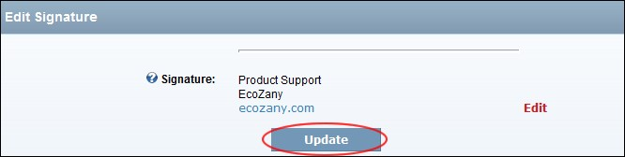

Editing any Forum User's Signature (This image displays Signature in Preview mode)

### Editing Global User Settings

How to edit the global user settings for the Forum module.

1. Go to the Forum Administration page. See "Navigating to the Forum Admin Page”
2. In the left-hand panel, select **Users** > **User Settings**. This displays the User Settings Management window.
3. At **Member Name Display**, select either Username or Display Name from the drop down list. This sets the format the sites users will appear to users of this forum module.
4. In the **Post Editing Time** text box, enter the number of minutes that users have to edit a previously posted item - OR - Enter 0 for indefinite editing.
5. **Optional.** At **Enable Auto Trust**, select from these options: mark  the check box if users will be trusted once they meet the Auto Trust threshold setting. This exposes the Auto Trust Threshold field where In the Auto Trust Threshold text box, enter the number of posts required before auto trust kicks in (if enabled). E.g. If this number is set to 100, after the untrusted user has their 100th post approved they will automatically have their trust status changed and their 101st post will go unmoderated (provided they have no other posts already in the queue). Note: If this setting is set to 0 (zero) all new users will automatically be trusted.
6. At **Lock New User Trust**, mark  the check box if user trust status can only be changed by administrators and not moderators- OR - unmark  the check box to disable.
7. At **Enable User Read Management**, mark  the check box if users are permitted to mark all threads as read and also clear read status of all thread items- OR - unmark the check box to prevent users from viewing these links (I.e. Community activity reporting can factor in thread reads).
8. At **User Signatures**, mark  the check box if to enable users to add a custom signature to their profile for the forum module. This signature displays in all posts as well as the users profile - OR unmark  the check box to disable.
9. At **Mod Signature Edits**, mark  the check box to enable moderators to update users' signatures from the user profile area which is viewable by all users- OR - unmark  the check box to disable.
10. At **HTML Signatures**, mark  the check box if users can use HTML code in their signatures- OR - unmark  the check box to disable.
11. At **User Banning**, mark  the check box to ban user - unmark  the check box to remove ban.
12. Click the **Update** button.

### Enabling User Avatars

How to enable users to upload one image for their profile that will be displayed in posts view and also in their profile.

1. Go to the Forum Administration page. See "Navigating to the Forum Admin Page”
2. In the left-hand panel, select **Users** > **Avatars**. This displays the Avatar Management window.
3. At **Enable User Avatars**, mark  the check box to enable users to upload an avatar (image) which is displayed in their profile and beside their posts.
4. At **Enable Profile Avatar**, select from these options:

  mark  the check box to check box make the system looks for avatars uploaded to the user’s core profile and complete these options.

1. At **Enable User Folders**, select from these options:

  mark  the check box to set the system to utilize the core profile image control. This means the path to the image will utilize user folders.

1. At **Profile Property**, select the profile property associated with user avatars in the core profile. Please note, this should be an Image Control data type property.

 unmark  the check box to disable and set these options:

At **Profile Property**, select the profile property associated with user avatars in the core profile. Please note, this should be an Image Control data type property.

In the **User Avatar Path** text box, modify the folder where the Avatars are stored. Avatars are stored in the site root directory. I.e. domain.com../../../../../Resources/. **Important.** Users must be given permission to add files to this folder.

* + unmark the check box to disable and complete these fields:
    - 1. In the **User Avatar Path** text box, modify the folder where the Avatars are stored.

Avatars are stored in the site root directory. I.e. domain.com../../../../../Resources/. **Important.** Users must be given permission to add files to this folder.

* + - 1. In the **User Avatar Dimensions** text boxes, enter the height and width in pixels (respectively) that avatars are displayed. The default setting is128 x128.
      2. In the **User Image Size Limit** text box, enter the maximum upload size in KB for the avatar image. The default setting is64.
      3. At **Enable Avatar Pool**, select from these options:

  mark  the check box to enable you to upload a folder of images for users to choose from to represent their profile avatar.

1. In the **Pool Avatar Path** text box, modify the folder where the Pool Avatars are stored if required.

 unmark the check box to disable.

1. At **Enable System Avatars**, select from these options:
   * mark  the check box to enable Administrators and Forum Administrators to assign avatar images to specific users of their choice. This is done per user, not by role.

1. **Optional.** In The **System Avatar Path** text box, modify the folder where the System Avatars are stored if required. Note: Forum Administrators must be given permission to view this folder.

* + unmark the check box to disable.

1. At **Enable Role Avatars**, select from these options:

  mark  the check box to assign avatar images based on roles.

1. In the **Role Avatar Path** text box, modify the folder where the Role Avatars are stored if required.

 unmark the check box to disable.

1. Click the **Update** button.

### Searching Forum User Accounts

How to search forum user accounts by username, email, display name, first name or last name.

1. Go to the Forum Administration page. See "Navigating to the Forum Admin Page”
2. In the left-hand panel, select **Users** > **Users**. This displays the User Management window.
3. Select from these two options:

**Option One:**

1. In the **Search** text box, enter the search criteria.
2. Select one of the following filters from the drop down list:
   * **All**: Returns all users whose account includes the criteria.  **Online**: View all online users who match the search criteria.  **Username**: View all for exact matches and all or part of the beginning of the username. E.g. Entering Ad, Admin, or A will return Admin.  **Display Name**: Searches for exact matches and all or part of the beginning of the display name. E.g. Entering R will return all names beginning with R.  **Email**: Displays partial and exact matches to the beginning of the email address.
   * **First Name** or **Last Name**: Searches for exact matches and all or part of the beginning of the name. E.g. Entering R will return all names beginning with R.

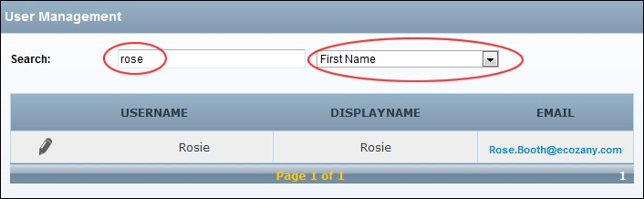

**Option Two:**

1. Select **Role** from the right-hand drop down list. This displays each role type in the left-hand drop down list.
2. Select the name of the role from the first drop down list.

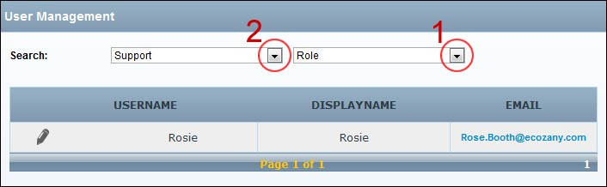

Related Topics:

 See "Editing any Forum User's Profile"

# Forum Members

## Adding a Bookmark to a Thread

How to add a bookmark to a thread in the Forum module. Threads with a bookmark are listed in your User Settings Control Panel.

1. Locate and open the required thread. See "Viewing any Post"
2. Click the **Add to Bookmarks**  button to add a bookmark – OR – Click the **Remove From Bookmarks**  button to remove the bookmark.

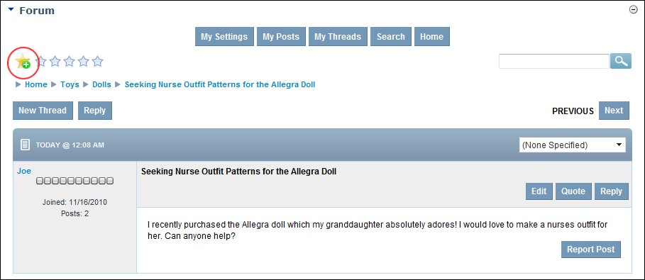

## Adding a Forum Post (Basic)

How to add an entry (commonly known as a post) to a forum in the Forums module. This tutorial covers the basic options which are available when the default settings are applied to the Forum module.

* 1. Navigate to the forum where you want to add the new post. See "Navigating to Forums & Forum Groups"
  2. Click the New Thread link.

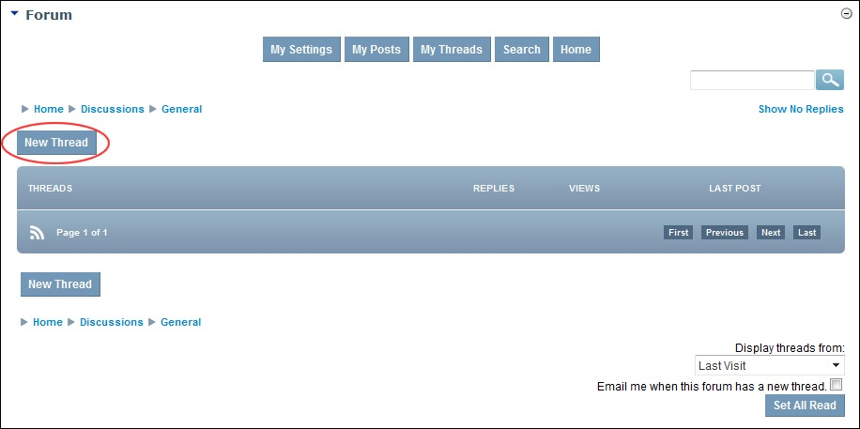

* 1. In the **Subject** text box, enter the subject of this post. This becomes the title of this post as it appears in the forum, therefore choose a subject that best describes the purpose and content of the post.
  2. In the **Editor**, enter the body of the post.
  3. **Optional.** At **Notification**, mark  the check box if you wish to receive an email when the post has a response.
  4. At **Thread Status**, select one of the following options:
     + **(None Specified)**: Select for no status to be displayed. This is the default option.
     + **Unresolved**: Select if the post asks a question requiring resolution.
     + **Resolved**: Select if the post is resolved or resolves a question. Typically this option is only selected when an existing post is answered.
     + **Informative**: Select if the post provides information.

1. **Optional.** At **Terms**, select one or more terms associated with this thread.
2. **Optional.** Click the Preview link to preview the post. If you wish to edit it further, click the Return To Edit link.

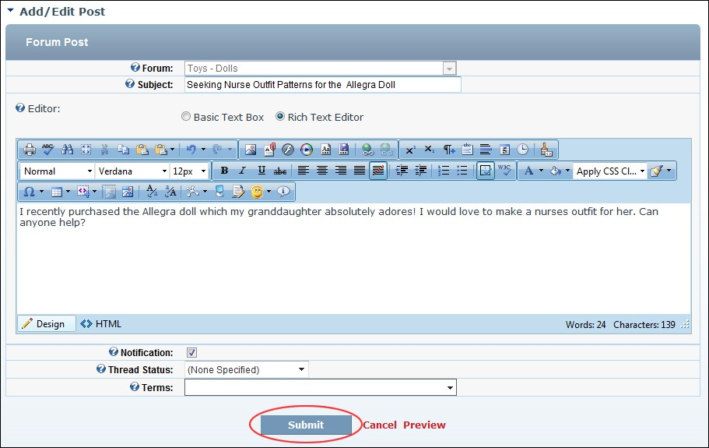

1. Click the Submit link. If the post doesn’t require moderation it is immediately added to the forum and is now displayed to you. If the post requires moderation a message is displayed explaining the moderation process. In this case, click the Return To Forum link.

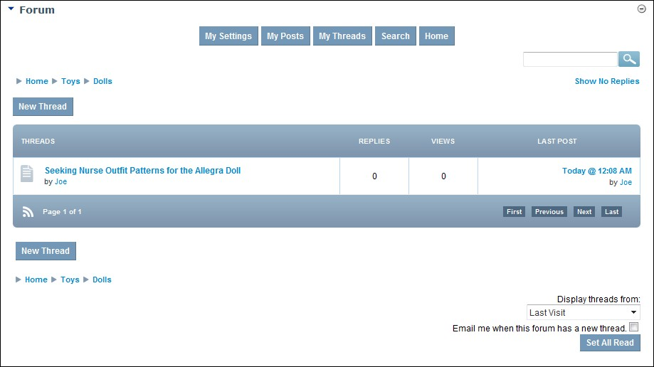

The Newly Added Post

## Adding a Forum Post (Advanced)

How to add an entry (commonly known as a post) to a forum in the Forums module. This tutorial covers the optional fields that can be enabled by Forum Administrators. See "Setting Forum Options" and "Setting Forum Permissions"

1. Navigate to the forum that you want to add the new post to. See "Navigating to Forums & Forum Groups"
2. Click the New Thread link.
3. In the **Subject** text box, enter the subject of the thread. This will be the title of the post as it appears in the forum so choose a subject that best describes the purpose and content of the post.
4. In the Editor, enter the body of the post.
5. **Optional.** At **Attachments**, select from these options:
   * To attach an attachment upload which was completed for this session or previously terminated sessions, select it from the **Uploaded Attachments** window. Note: You can delete an uploaded file, by selecting it from the list and then clicking the **Delete**  button.
   * To upload a new attachment, click the **Browse** button and select the file to be attached from your computer and then click the Upload link.
6. **Optional.** At **Pinned**, mark  the check box to 'pin' this post above existing posts in this forum, or unmark  the check box to have the post appear in date/time order as is typical.
7. **Optional.** At **Notification**, mark the check box to be notified when a reply is made to this post or unmark the check box to disable notification.
8. **Optional.** At **Locked**, mark  the check box to prevent others from replying to this post or unmark  the check box to permit replies.
9. **Optional.** At **Thread Status**, select one of the following options:
   * **(None Specified)**: select for no status to be displayed. This is the default option.
   * **Unresolved**: select if the post asks a question requiring resolution.
   * **Resolved**: select if the post is resolved or resolves a question. Typically this option is only selected when an existing post is answered.
   * **Informative**: select if the post provides information.
10. **Optional.** At **Terms** click the drop down list and then check the check box beside a term which relates to this post. Repeat the above step to associate additional terms.
11. **Optional.** Click the Preview link to preview the post. If you wish to edit it further, click the Return To Edit link.
12. Click the Submit link. If the post doesn’t require moderation it is immediately added to the forum and is now displayed to you. If the post requires moderation a message is displayed explaining the moderation process. In this case, click the Return To Forum link.

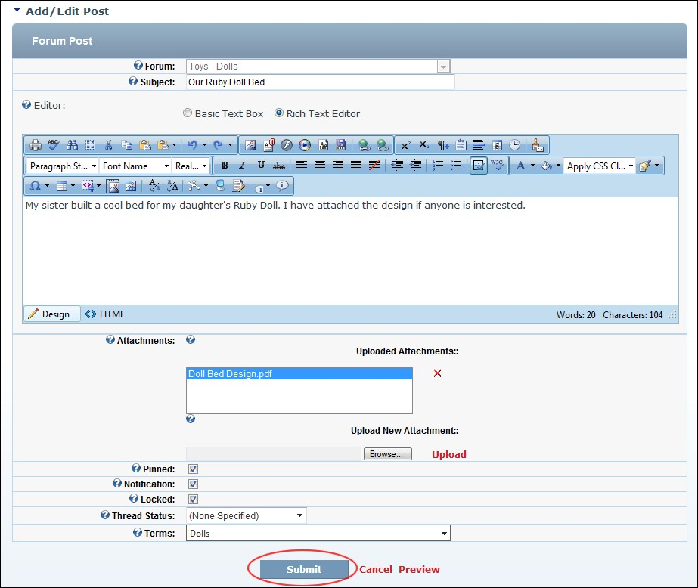

Adding a Post Including Attachments and Optional Settings

## Deleting a Forum Post

How authorized users can permanently delete a post from the Forum module.

* 1. Locate and open the required post. See "Viewing any Post"
  2. Click the Delete link located to the right of the post title.

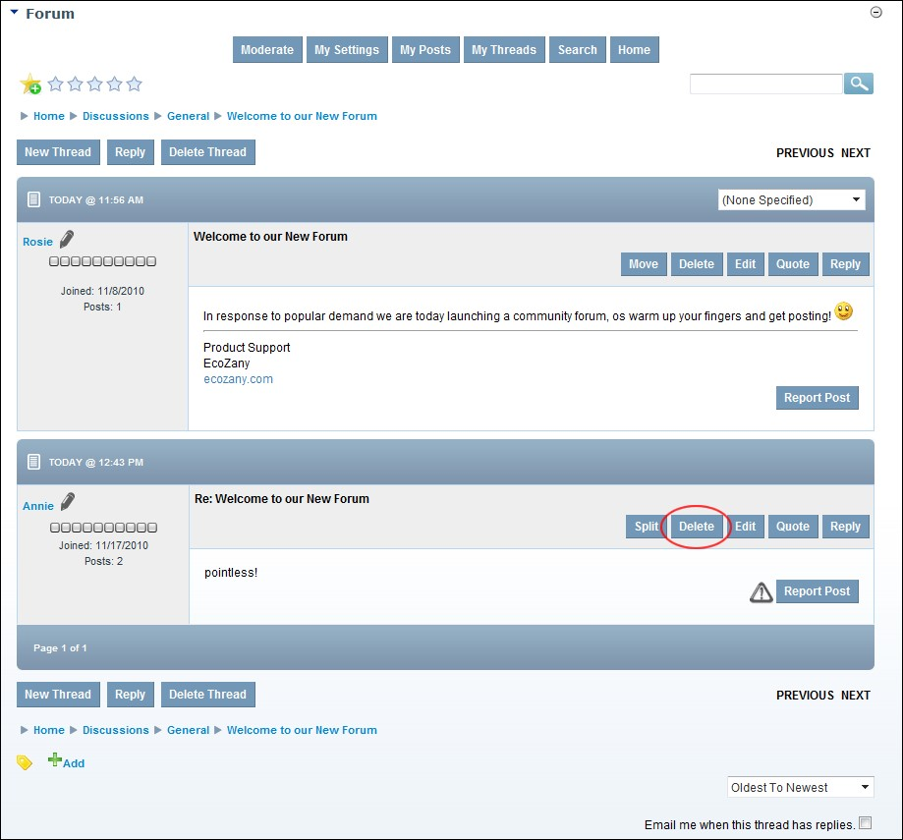

* 1. **Optional.** Complete this step to send email notification to the poster that this post has been deleted:
     1. At **Email Template**, select the reason why the post is being deleted.
     2. **Optional.** In the **Emailed Response**, edit the message to be emailed to the poster.
     3. At **Email User**, mark  the check box to email the poster.
     4. Click the Delete link and then click the **OK** button to confirm.

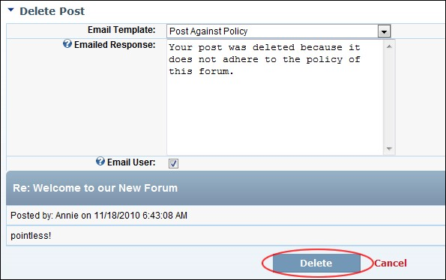

Deleting a Post

## Editing your Forum Posts

How a forum member can edit their own posts on the Forum module. Note: Post editing maybe restricted to a number of minutes following the original posting.

* + 1. View your threads. See "Viewing your Threads"
    2. Locate the required post and then open it by clicking on the [post title] link.
    3. Click the Edit link located to the right of the post title. This opens the Add/Edit Post page. 4. Edit the subject or body or attach files as required. See "Adding a Forum Post (Advanced)"

5. Click the Submit link. The post is immediately added to the forum and displayed to you.

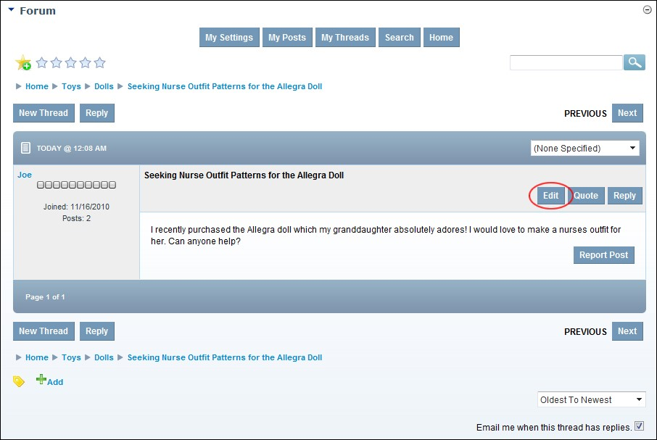

Editing Your Post

Related Topics:

 See "Editing Global User Settings"

## Editing your Forum Profile

How to edit your user profile via the Forum module. Note: This tutorial explains how to manage your user profile when the Forum module uses the core DNN User Profile. Where an alternate non-core module is used, you must follow instructions provided by your module developer from Step 2.

* + 1. Select **My Settings** from the module actions menu - OR - Click the My Settings link. This opens the User Settings page. The Control Panel > Overview window is displayed.
    2. In the right-hand panel, select **Profile** > Edit Profile to displays your User Profile for this site and modify as required.

## Editing your Forum Settings

How to manage your forum settings using the Forum module.

* + 1. Go to the Forum Administration page. See "Navigating to the Forum Admin Page"
    2. In the left-hand panel, select **Forum** > **Edit Settings**. This displays the User Forum Settings window.
    3. At **Email Format**, select **HTML** or **Text**.
    4. In the **Threads Per Page** text box, enter the number of threads to be displayed on one page at one time. The default setting is 10. Note: Authenticated Users can override this setting for themselves on the My Settings page.
    5. In the **Posts Per Page** text box, enter the number of posts to be displayed on one page at one time. The default setting is 5. Note: Authenticated Users can override this setting for themselves on the My Settings page.
    6. At **Notify on Reply**, mark  the check box if the users will receive notification of replies in threads they have posted in. Note: They can opt-out of notifications when they post - OR - unmark  the check box to disable.
    7. At **Enable "My Post" Notify**, mark  the check box if the users will receive email notification of their own posts- OR - unmark  the check box to disable.
    8. At **Moderator Emails**, mark  the check box if the users will receive email notification of new posts awaiting moderation - OR - unmark  the check box to disable.
    9. At **Clear All Read Status**, click the Clear Read Status link to clear all read status for all forums and threads for this user.
    10. Click the **Update** button.

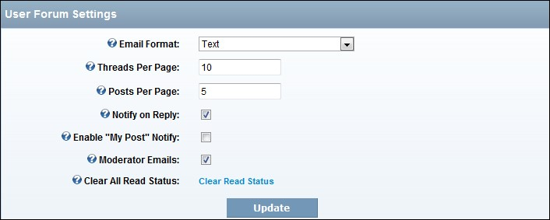

Editing Your Forum User Settings

## Editing your Forum Signature

How to edit your forum signature using the Forum module.

1. Select **My Settings** from the module actions menu - OR - Click the My Settings link. This opens the User Settings page. The Control Panel > Overview window is displayed.
2. In the right-hand panel, select **Profile** > Edit Signature. This displays the Edit Signature page.
3. In the **Signature** text box, add/edit your signature. Basic HTML formatting maybe disabled.



1. **Optional.** Click the Preview link to preview the signature and then click the Edit link to edit this signature.
2. Click the **Update** button.



Editing Your Signature (This image displays Signature in Preview mode)

## Manage Notifications

How to manage your notifications for forums and threads which you have chosen to track using the Forum module.

* + 1. Select **My Settings** from the module actions menu - OR - Click the My Settings link. This opens the User Settings page. The Control Panel > Overview window is displayed.
    2. In the right-hand panel, select **Control Panel** > Notifications. This displays the Tracked Forums and Threads window with the Forums tab selected.
    3. On the Forums tab you can click on the **Delete**  button beside a thread to stop tracking it; click on the [Forum Name] link to go to that forum; and click on the [Date/Time] link to view the last post.
    4. On the Threads tab you can perform the following:

## Managing Forum Bookmarks

How to manage your thread bookmarks which you have chosen to track using the Forum module.

* + 1. Select **My Settings** from the module actions menu - OR - Click the My Settings link. This opens the User Settings page. The Control Panel > Overview window is displayed.
    2. In the right-hand panel, select **Control Panel** > Bookmarks. This displays the Bookmarks window. Here you can click on the **Delete**  button beside a bookmark to remove the bookmark; click on the [Thread Name] in the **Subject** column to view the thread; and click on the [Date/Time] link in the **Last Post** column to view the latest post.

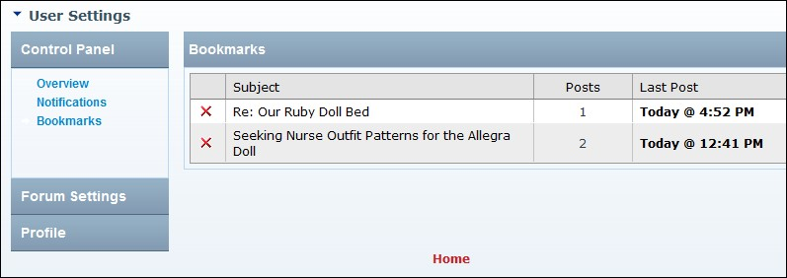

Related Topics:

* + - * See "Adding a Bookmark to a Thread"

## Moving a Thread

How to move a thread to a new forum in the Forum module. Moderators require moderate permissions on the particular forum to move a thread. See "Setting Forum Permissions"

1. Locate and open the required thread. See "Viewing any Post"

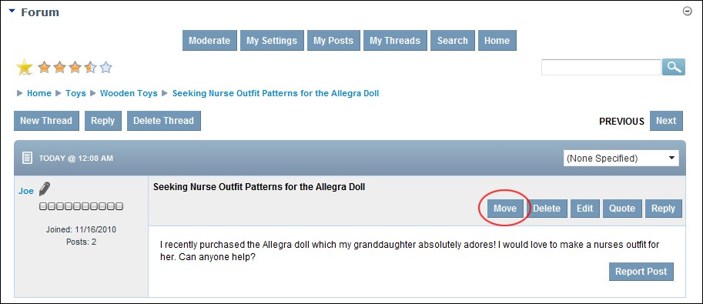

* + 1. Click the Move link beside the post. This opens the Move Thread page.
    2. At **New Forum**, mark  the check box associated with the new forum for this new thread.
    3. **Optional.** At **Email Users of Thread Move**, mark  the check box to notify all users participating in this thread that this thread has been moved - OR - unmark  the check box for no email notification.

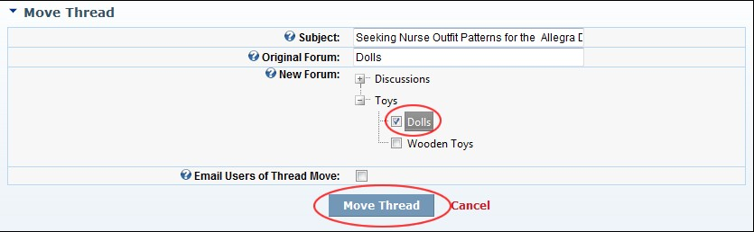

* + 1. Click the Move Thread link.

## Quoting a Post

How to quote an existing forum post when replying it on the Forum module. Quoting adds the name of the poster and the content of the post to the post you are adding.

* 1. Locate and open the required post. See "Viewing any Post"

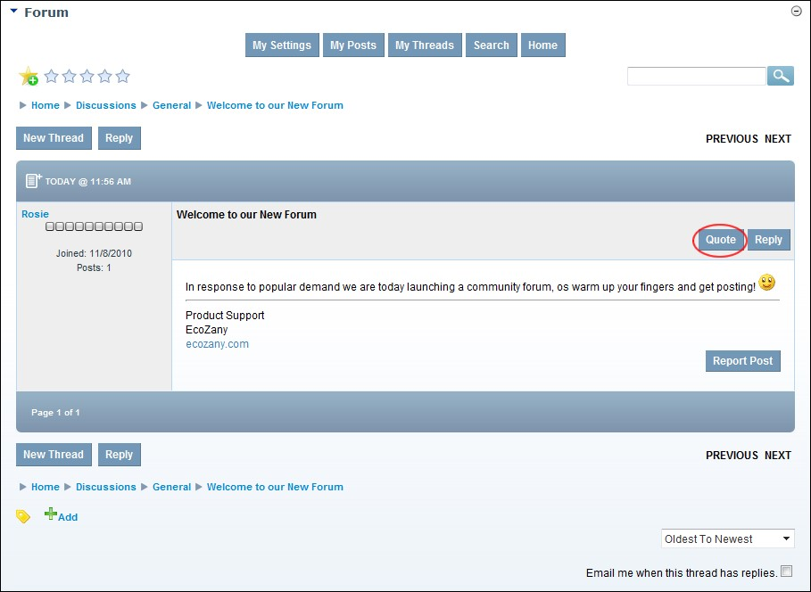

* 1. Click the Quote link located to the right of the post title. This opens the Add/Edit Post page which displays the quoted post in the Editor.
  2. In the **Editor**, add your post in reference to the quote.
  3. **Optional.** At **Notification**, mark  the check box to receive an email when the post has a response.

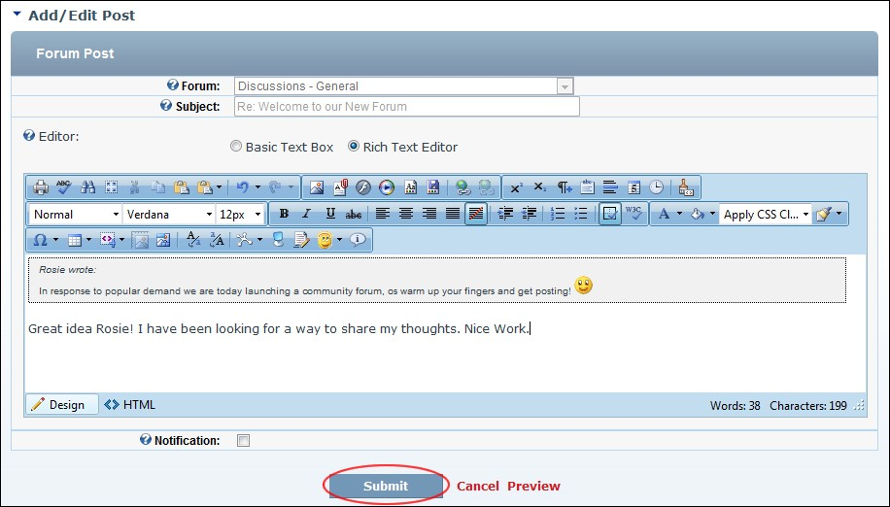

* 1. Click the Submit link. If the post doesn’t require moderation it is immediately added to the forum and is now displayed to you. If the post requires moderation a message is displayed explaining the moderation process.

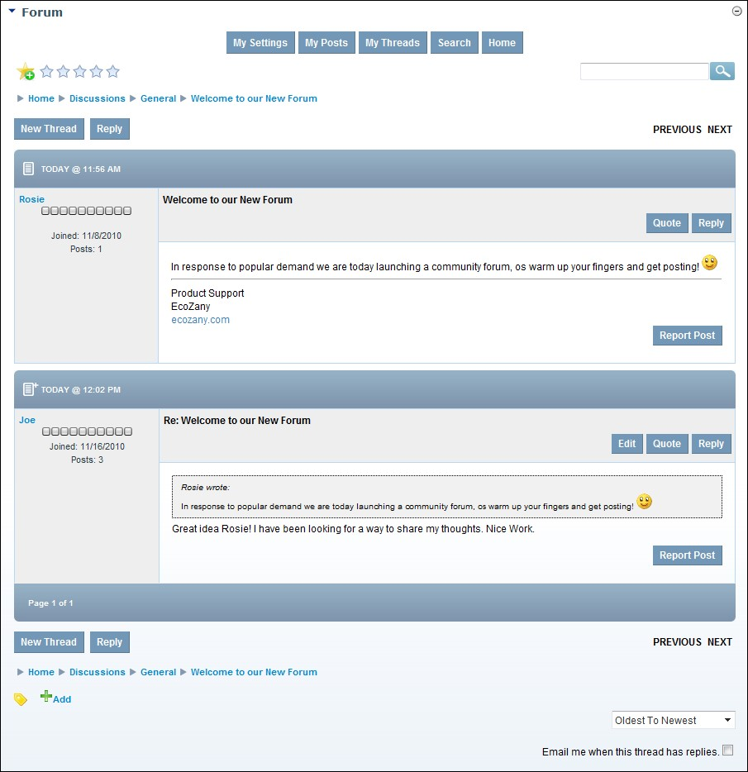

The Quoted Post

## Rating a Thread

How to add a rating to a thread in the Forum module. Note: Ratings may be disabled on some or all forums.

* + 1. Locate and open the required thread. See "Viewing any Post"
    2. In the top right-hand corner of the module, a series of Stars are displayed.

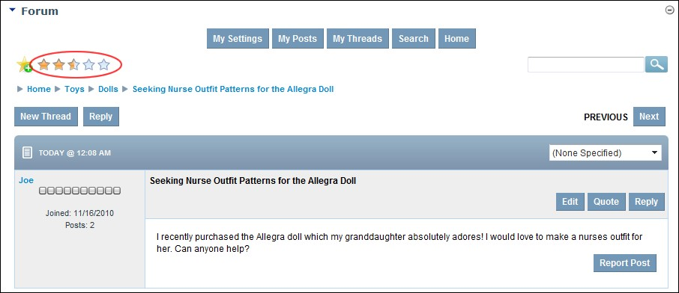

* + 1. Click on the star rating that you want to give. This adds your rating to all existing ratings and displays the average rating on the thread.

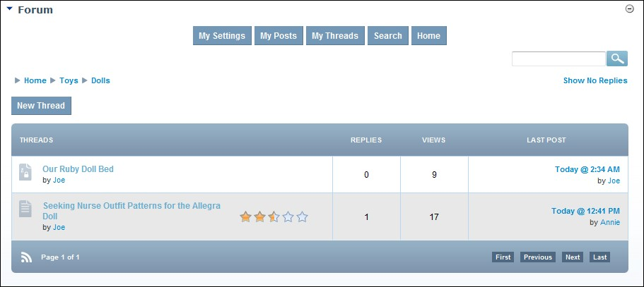

The Rated Thread

## Replying to a Post

How to reply to a post in the Forum module.

* + 1. Locate and open the required post. See "Viewing any Post"
    2. Click the Reply link located top right above the post. This opens the Add/Edit Post page which displays the post in the Editor.
    3. In the **Editor**, enter your post, any attachments and set optional fields as required. See "Adding a Forum Post (Advanced)"
    4. **Optional.** At **Notification**, mark  the check box to receive an email when the post has a response.
    5. Click the Submit link.

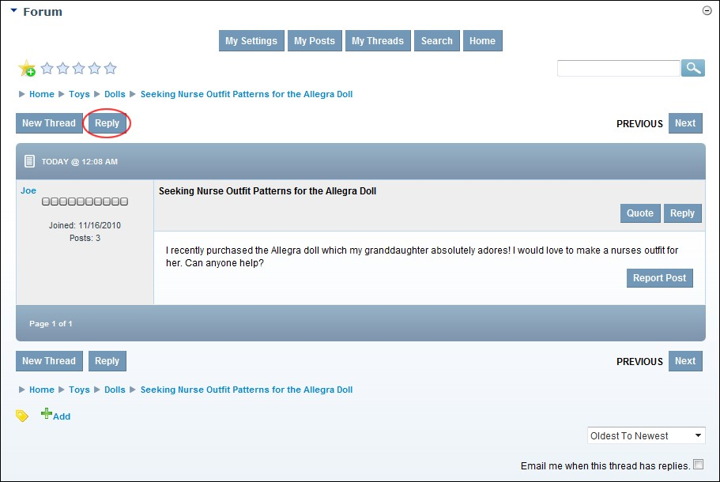

Replying to post

## Reporting a Post

How to report an inappropriate post on the Forum module. This sends a report email to the associated Forum Moderators/Administrators. Note: This option maybe disabled.

* 1. Navigate to the post. See "Viewing any Post"

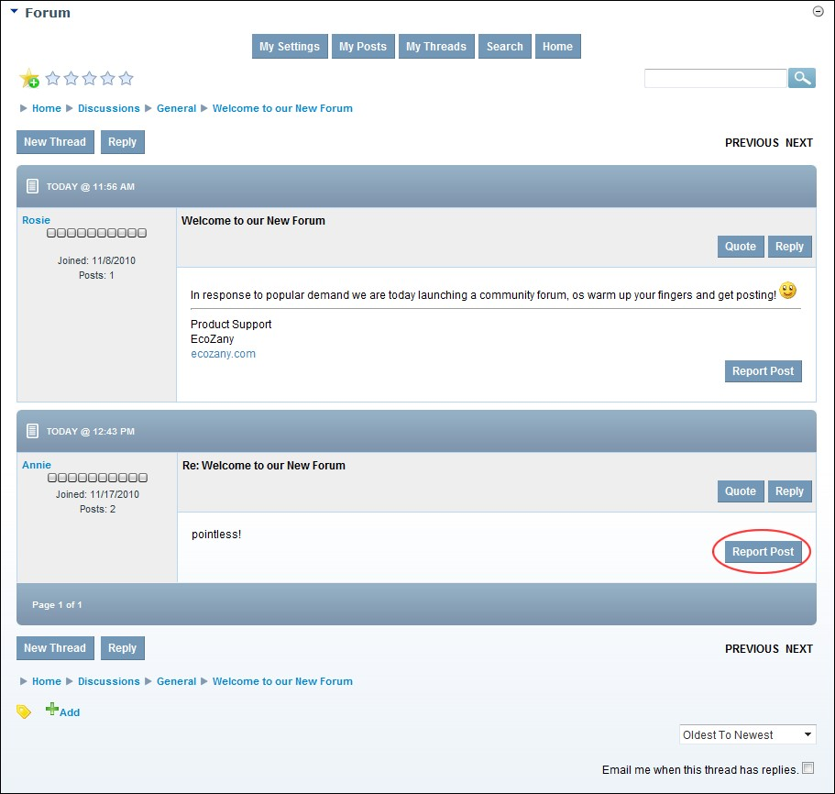

* 1. Click the Report Post link. This opens the Report Post page.
  2. At **Email Template**, select the reason for reporting the post from these options: Post is Duplicate, Post is Against Policy, Post is Spam, Post Off Topic, Post Contains Profanity, or Post Contains Excessive Advertising.
  3. **Optional.** In the **Emailed Response** text box, edit email message.

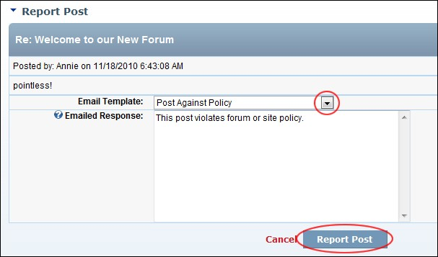

1. Click the Report Post link and then click the **OK** button to confirm. The post now displays the **Report Warning**  icon. Mouse over the icon to view the number of reports against this post.

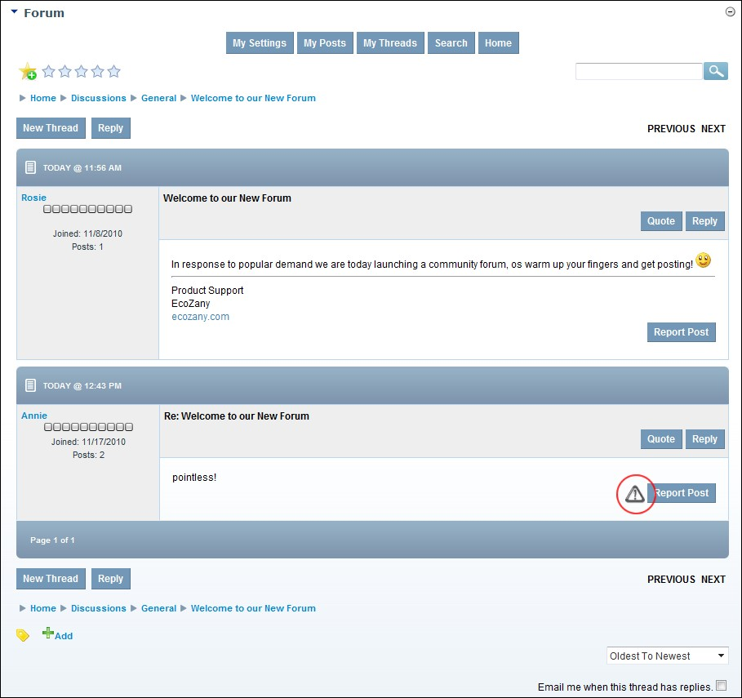

A Reported Post

## Setting Thread Status

How to set the status of a thread in the Forum module. This setting can be a useful housekeeping tool which helps users to quickly identify when a post is informative or when a question is or isn't answered. Note: This option maybe disabled.

* + 1. Locate and open the required post. See "Viewing any Post"
    2. At the (None Specified) drop down list, select either **None Specified**, **Unresolved**, **Resolved**, or **Informative**.

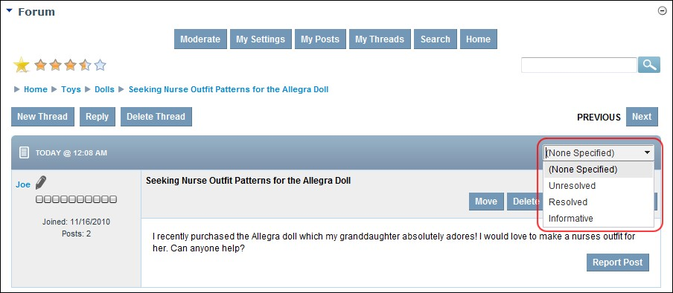

Setting Thread Status

## Splitting a Thread

How to split a post from its current thread and start it as a new thread in the Forum module. Moderators require moderate permissions on the particular forum to split a thread. See "Setting Forum Permissions"

* 1. Locate and open the required post. See "Viewing any Post"

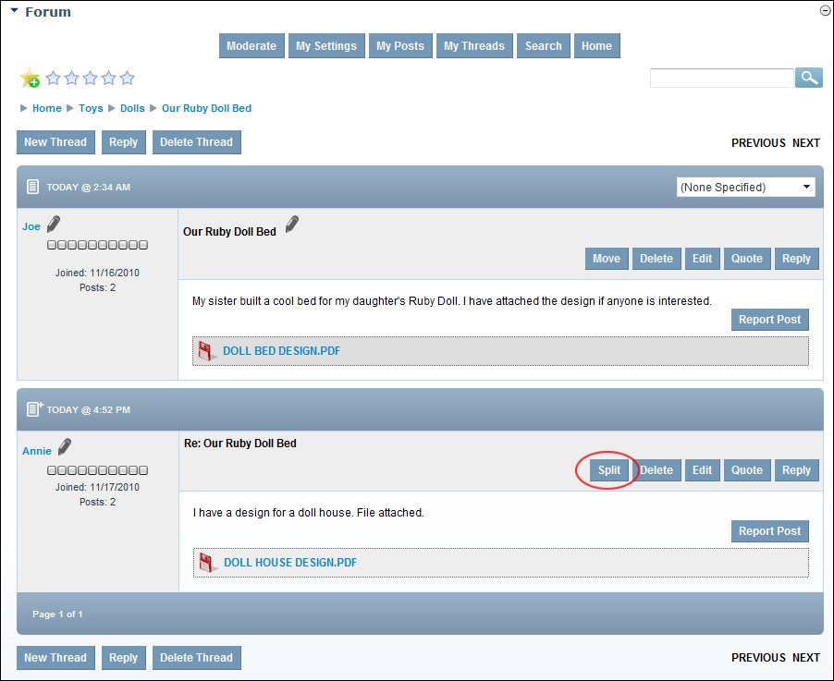

* 1. Click the Split link beside the post. This displays the Split Thread page.
  2. At **Splitting Post**, you can view the title of the first post of the new thread being created by splitting this existing one
  3. At **New Forum**, mark  the check box associated with the new forum for this split thread.
  4. **Optional.** At **Email Post Authors**, mark  the check box to notify all users participating in this thread that this thread has been moved - OR - unmark  the check box for no email notification.

1. Optional. At **Include Post In New Thread**, mark  the check box to include other posts in this thread - OR - unmark  the check box to only include the post selected for splitting. E.g. the first post listed here.
2. Click the Split Thread link. This displays the message "All Posts which are not approved and are being split into the new thread will be approved during the split!"
3. Click the **OK** button to confirm.

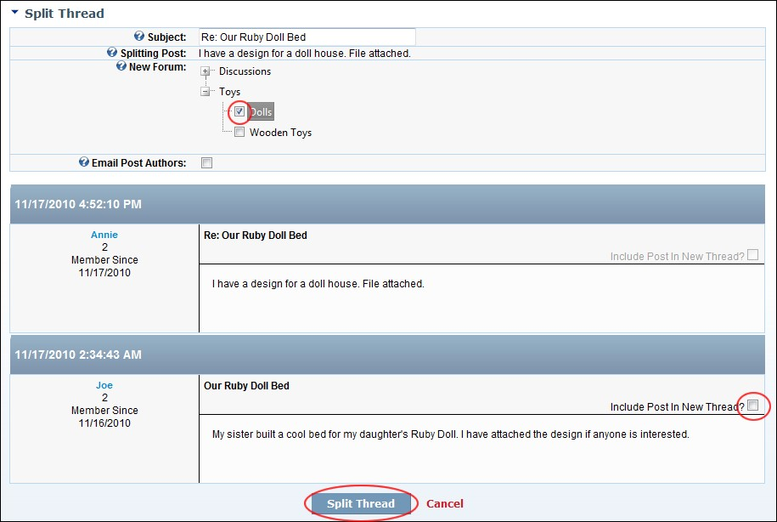

Splitting a Thread

## Viewing your Posts

How a forum member can view all of their posts to the Forum module.

Tip: When viewing a thread, you can order it from Oldest To Newest or Newest To Oldest by selecting either option from the drop down list located in the bottom right corner of the page.

* + 1. Select My Posts from the module actions menu - OR - Click the My Posts linking the top center of the Forum module. This displays a list of your posts.
    2. **Optional.** Click on the [Post Title] link to view the associated thread.

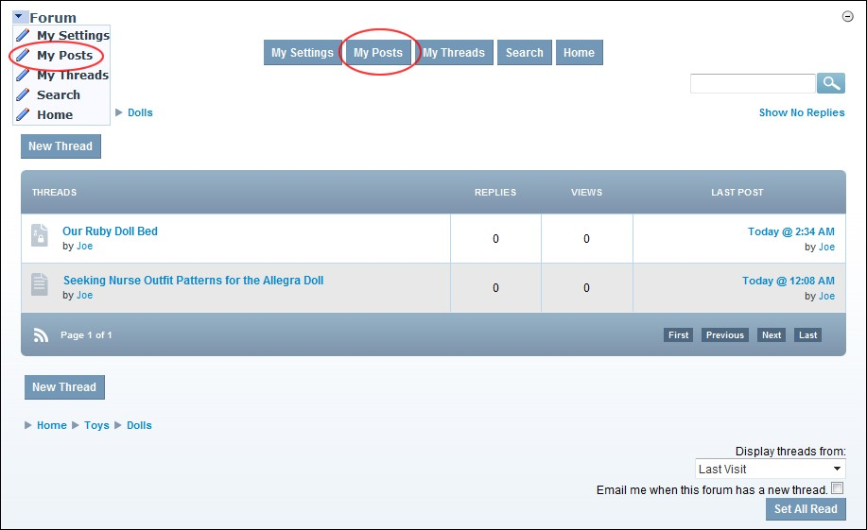

Viewing Your Posts

## Viewing your Threads

How a forum member can view all of their threads to the Forum module.

* 1. Select My Threads from the module actions menu - OR - Click the My Threads linking the top center of the Forum module.

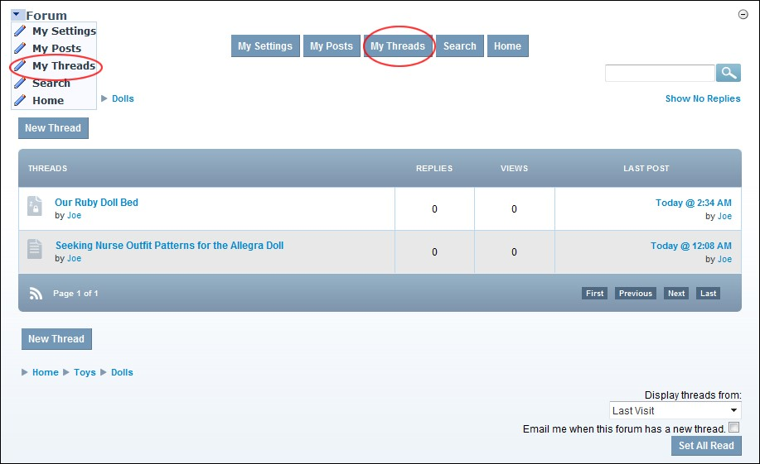

* 1. **Optional.** Click on the title of a thread to view it in full.

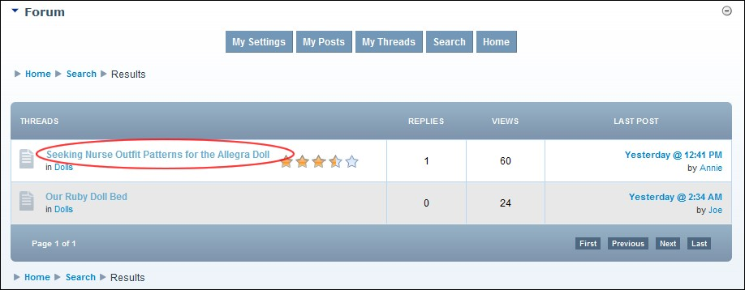

# Forum Moderators

## Approving a Post

How forum moderators and Administrators can approve a post to a moderated forum.

1. Go to the moderator post queue. See "Navigating to the Moderator Post Queue"
2. In the Forum column, click on a [Forum Name] link to view posts requiring moderation in that forum.

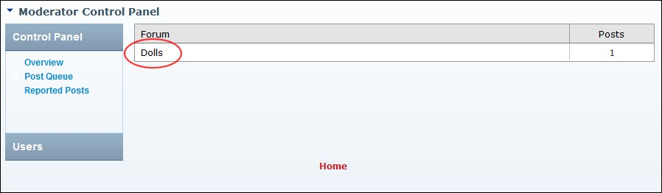

1. Click the Approve link beside the post to be approved.

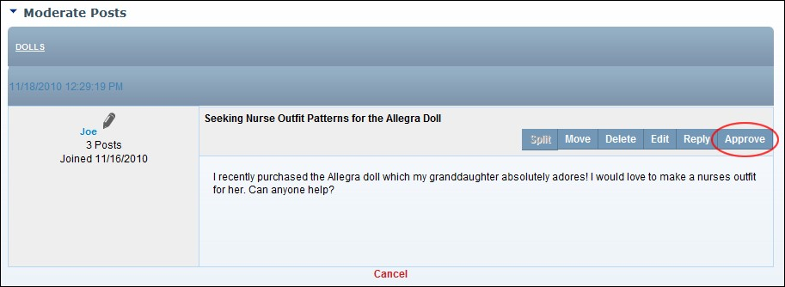

1. Repeat Step 3 to approve additional posts.
2. Click the **Cancel** button to return to the module.

## Approving and Editing a Post

How forum moderators and administrators can approve a post and edit the content of the post. E.g. Spelling or grammatical errors.

1. Go to the moderator post queue. See "Navigating to the Moderator Post Queue"
2. In the Forum column, click on a [Forum Name] link to view posts requiring moderation in that forum.



1. Click the Edit link beside the required post. This opens the Add/Edit Post page.
2. Edit the post in the Editor.
3. **Optional.** Edit one or more of these settings:
   1. At **Attachments**, modify the attachments if required.
   2. At **Pinned**, mark  the check box to set this post to always appear at the top of the related forum group.
   3. At **Notification**, mark  the check box if you wish to be notified of replies to this post.
   4. At **Locked** mark  the check box to disable replies to this post.
   5. At **Thread Status**, update the status as required. E.g. Informative
   6. At **Terms**, click the drop down list and then mark  the check box beside a term which relates to this post.

1. Repeat the above step to associate additional terms.

1. **Optional.** Click the Preview link to preview the edited post.
2. Click the Submit link.

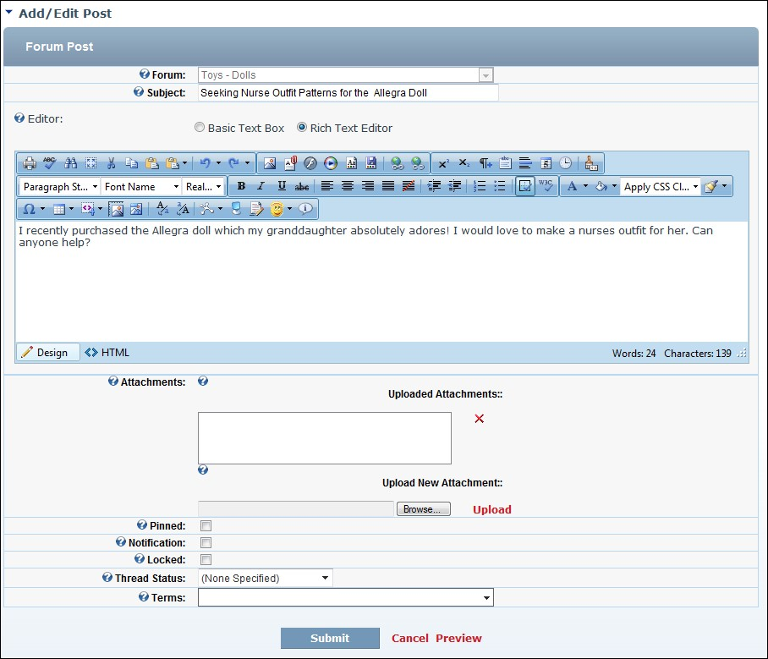

Approving and Editing a Moderated Post

## Approving and Replying to a Post

How to approve a post and add reply to the post.

1. Go to the moderator post queue. See "Navigating to the Moderator Post Queue"



1. In the Forum column, click on a [Forum Name] link to view posts requiring moderation in that forum.

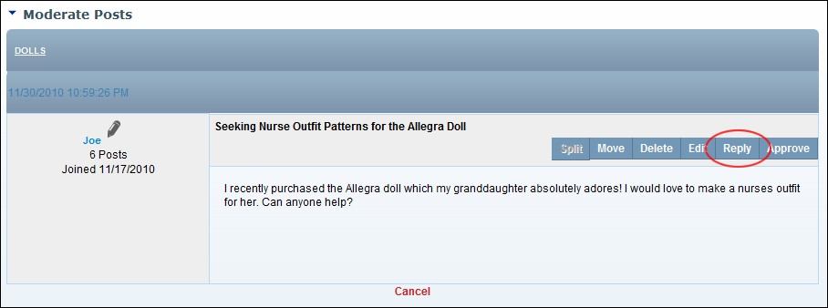

1. Click the Reply link beside the required post. This opens the Add/Edit Post page.
2. Enter your reply in the Editor.
3. **Optional.** Add/set one or more of these settings:
4. At **Attachments**, modify the attachments if required.
5. At **Pinned**, mark  the check box to set this post to always appear at the top of the related forum group.
6. At **Notification**, mark  the check box if you wish to be notified of replies to this post.
7. At Locked, mark the check box to disable replies to this post.
8. **Optional.** Click the Preview link to preview the edited post.
9. Click the Submit link.

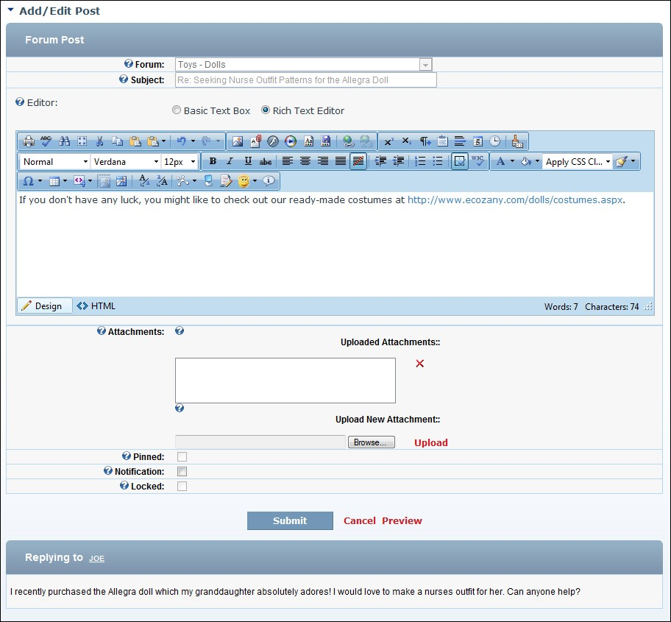

Approving a Moderated Post and adding a Reply

## Approving and Splitting a Post awaiting Moderation

How to split a post in the moderation queue from its current thread and start it as a new thread in the Forum module.

* 1. Go to the moderator post queue. See "Navigating to the Moderator Post Queue"
  2. In the Forum column, click on a [Forum Name] link to view posts requiring moderation in that forum.



* 1. Click the Split link beside the required post. This opens the Add/Edit Post page.
  2. Enter your reply in the Editor.
  3. **Optional.** Add/set one or more of these settings:
     1. At **Attachments**, modify the attachments if required.
     2. At **Pinned**, mark  the check box to set this post to always appear at the top of the related forum group.
     3. At **Notification**, mark  the check box if you wish to be notified of replies to this post.
     4. At **Notification**, mark  the check box if you wish to be notified of replies to this post.
     5. At **Locked**, mark  the check box to disable replies to this post.
     6. **Optional.** Click the Preview link to preview the edited post.
  4. Click the Submit link.

## Deleting a Post awaiting Moderation

How a forum moderator or an Administrator can delete a forum post in the moderation queue. These posts never appear on the site. A response explaining the reason for the deletion is emailed to the poster.

* 1. Go to the moderator post queue. See "Navigating to the Moderator Post Queue"
  2. In the Forum column, click on a [Forum Name] link to view posts requiring moderation in that forum.



* 1. Click the **Delete** button. This opens the Delete Post page where you can edit and/or view the email template sent to the poster.
  2. At **Email Template**, select the reason why the post is being deleted. This populates the Emailed Response text box below with a standard message for the selected reason.
  3. **Optional.** At **Emailed Response**, edit the text of the email if required.
  4. **Optional.** At **Email User**, mark  the check box to email the poster - OR - unmark  the check box if no email is required.
  5. Click the Delete link and then click the **OK** button to confirm.

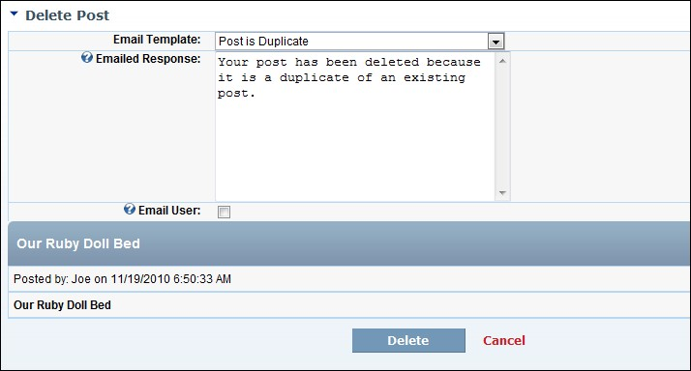

Deleting a post awaiting moderation

## Managing Reported Posts

How to manage posts that have been reported.

* 1. Select **Moderate** from the module actions menu - OR - Click the Moderate link. This opens the Moderator Control Panel.

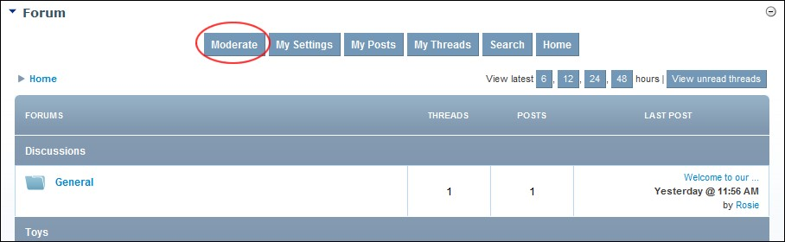

* 1. In the left-hand panel, select **Reported Posts**. This displays a summary list of reported posts.
  2. In the **Post** column, click on a post title link to view the post in full.
  3. Optional. Click the **Click To Address Report** button to address this reported post and address as required.

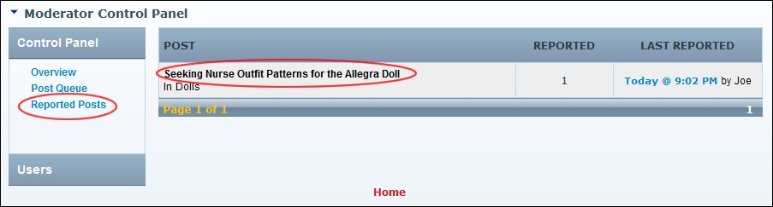

## Navigating to the Moderator Post Queue

How to navigate to the location where moderators can view and manage forum posts awaiting moderation.

* 1. Select **Moderate** from the module actions menu - OR - Click the Moderate link. This opens the Moderator Control Panel.



* 1. In the left-hand panel, select **Post Queue**. This displays a summary list of forums with posts awaiting approval.

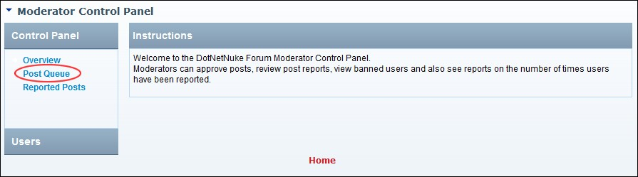

## Viewing Banned Users

How to view a list of users who are been banned from the Forum module.

* 1. Select **Moderate** from the module actions menu - OR - Click the Moderate link. This opens the Moderator Control Panel.



* 1. In the left-hand panel, select **Users** > **Banned**. This displays a summary list of banned users.
  2. In the User column, click on a user name link to view the users profile.

Related Topics:

 See "Editing Global User Settings"

## Viewing Reported Users

How to view the profile of users who are been reported on the Forum module.

* 1. Select **Moderate** from the module actions menu - OR - Click the Moderate link. This opens the Moderator Control Panel.



* 1. In the left-hand panel, select **Users** > **Reported**. This displays a summary list of reported users.
  2. In the **User** column, click on a user name link to view the users profile.

# Settings

## Default Forum

How to set the default forum for this instance of the Forum module. Note: These settings are stored on a per page/module basis so even a copy of a module can have a different default forum.

1. Select  **Manage** >  **Settings** from the module actions menu.
2. Go to the **Forum Settings** section.
3. At **Default Forum**, **Maximize**  the forum group where the required forum resides and mark  the required forum.
4. Click the **Update** button.

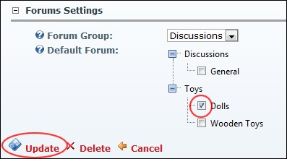

Setting the Forum Group for a Forum Module

## Setting a Single or Aggregated Forum Group

How to pull content from the parent forum into a child forum using the Forum module. The parent forum is the forum where all forum groups and forums are created. The child forum is an instance of the existing parent module, set to only show the select forum group.

Note: These settings are stored on a per page/module basis so even a copy of a module can have a different default group.

1. Add an existing Forum module.
2. Select  **Manage** >  **Settings** from the module actions menu.
3. Go to the **Forum Settings** section.
4. At **Forum Group**, select**:**
   * **All Groups**: Select to display all forum groups in this module.
   * **Aggregated**: Select to automatically direct users to the aggregated thread view since only a single forum can possibly exist in that group.
   * **[Group Name]**: Select the name of a forum group to only display that group in this module.

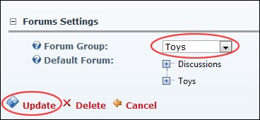

1. Click the **Update** button.

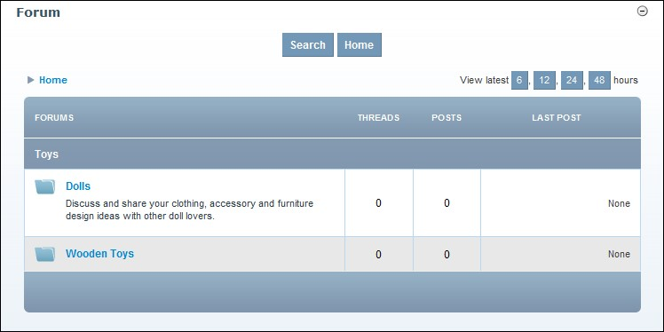

A Single Forum Group display in an instance of the Forum Module

## Setting Additional Forum Permissions

How to set the unique permissions for the Forum module.

1. Select  **Manage** >  **Settings** from the module actions menu.
2. Select the **Permissions** tab.
3. **Optional.** In the **Username** text box, enter the username of a user to whom you wish to grant or deny module permissions and then click the Add link. Repeat for additional usernames.
4. **Optional.** At **Filter By Group**, select from the following options:
   * **< All Roles >**: Select to view all roles (both global and group roles) in one single list.
   * **< Global Roles >**: Select to view all roles which are not associated with a Role Group. This includes Administrators, All Users, Registered Users and Unauthenticated Users.
   * **[Role Name]**: Select the name of a Role Group to view the roles within that group.
5. In the **Forum Administrator** column, mark  the check box for each role that is able moderate one or more forums.
6. In the **Global Administrator** column, mark  the check box for each role that is able moderate all forums and access the Forum Admin page and manage all related settings.

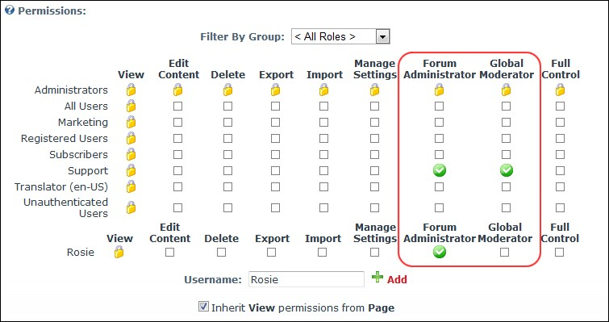

1. Click the **Update** button.